ESTABLISHMENT OF BASESTATION
TRIMBLE – R8 (Static Method )

I ) Step
Base Station Fixing on Known SOI Control Point.

Set up a Tripod with tribrach and adaptor over a Permanent Known Control point.
And Align the horizontal and Vertical Bubble centre.
Twist on the 0.25 mt Range pole to the tribrach adapter centerpiece and Lock the tribrach and adaptor.
Measure the Height from Ground Center to Receiver centre of bumper. ( In Mts)
Twist the R8 Base Receiver to the pole. And Power up the Receiver.( Green Button)
II) Step
Base Controller Setup

Press Green button for Power on the Controller.

Start | :- | Trimble Access
Press Button | :- | Survey Styles
Select Method | :- | Static
Select Option | :- | Base Option
Fallow the Base Controller Setups
Survey Type | :- | Fast Static
Logging Interval | :- | 1 S
Elevation Mask | :- | 10°
Logging Device | :- | Controller
Antenna | :- | R8 GNSS/SPS88X
Press Next Screen |  | ⅓
Measured to | :- | Center of Bumper
Antenna Height | :- | m
Serial No | :- | 5126468628
Press Next Screen |  | ⅔
GPS L2C | :- | √ ( Yes)
GLONASS | :- | √ ( Yes)
 |  | 3/3
Press | :- | Accept Button
Press | :- | Store Option

Press Esc Button
Now Your in Setting Screen Close this screen.
Now Your in Trimble Access Screen.

III ) Step ( Create BaseJob and BaseFile )

Select General Survey Button
Select Jobs
Create New Job

Job Name | :- | 8-Aug-13
Template | :- | Default
Coord .Sys | :- | 1:00000000
 |  | Press Here
Select from | :- | Library
System | :- | UTM
Zone | :- | 44 North | Before Going to survey check UTM zone ( 43 / 44 / 45 )
Datum | :- | Wgs 1984 ( 7P)
Use Goid Model | :- | No
Use Datum Grid | :- | No
Press Next Screen |  | 1/2 | Ending Page 1
Co ordinate | :- | Grid
Project Height | :- | 500 | Hyderabad surroundings it is nearly 500 m.
 |  | 2/2 | Ending Page 2
Press | :- | Store Button
Press | :- | Accept Button

Now you are in Present Job. ( Example :- 8-Aug-2013).

IV ) Collecting Base Point.

Select --------→ Instruments-----→ GNSS Function------→Base Mode.

Press---------→ Escape

Press ---→ Measure--→ Static-→ Start Base Receiver.

Point Name | :- | Base-8 Aug | Surveyor option
Select |  | Keyin
Northing | :- | 1926162.274 | Known Value enter
Easting | :- | 230974.082 | Known Value enter
Height | :- | 471.212 | Known Value enter
Antenna Height | :- | 1.730 m | Ground center to Center of Bumper
Measure to | :- | Center of bumper

Press -→ Store
Press-→ Start

Now Base is Started .

1
2
3
8
5
6
7
9
4
10
11
12
13
14

14
V) Enable the Gagan Correction Signal :-

Press No of Satellites available :-

Press Options

Controller Display
Elevation Mask | :- | 10°
PDOP | :- | 6.0
Enable WAAS/EGNOS | :- | √ ( Yes)

Press----→ Accept

Press---→ Escape.

Now Base is Started .

ROVER Settings

Rover Fix at place where control point shall be Established.
I ) Set up a Tripod with tribrach and adaptor over a Control point shall be established.
And Align the horizontal and Vertical Bubble centre.
Twist on the 0.25 mt Range pole to the tribrach adapter centerpiece and Lock the tribrach and adaptor.
Measure the Height from Ground Center to Receiver centre of bumper. ( In Mts)
Twist the R8 Rover Receiver to the pole. And Power up the Receiver.( Green Button)

Start | :- | Trimble Access
Press Button | :- | Survey Styles
Select Method | :- | 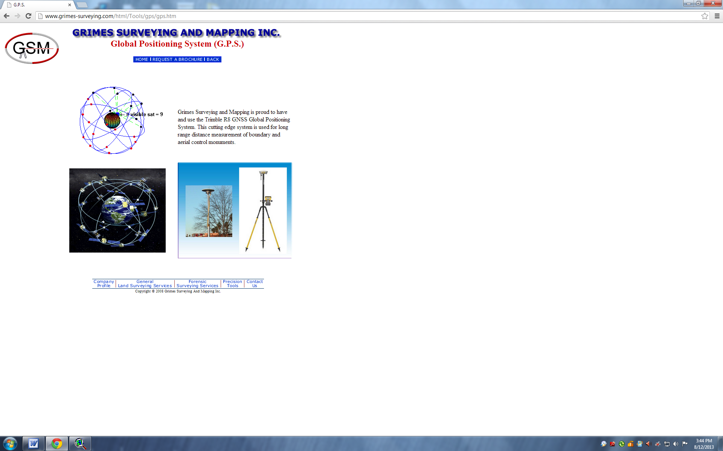  Static
Select Option | :- | Rover Option
Press Next Screen |  | ⅓ Ending page 1
Antenna Height | :- | m
Remaining No change default only
Press Next Screen |  | ⅔ Ending page 2
Tracking L2e | :- | √ ( Yes)
GPS L2C | :- | √ ( Yes)
GLONASS | :- | √ ( Yes)
 |  | 3/3 Ending page 3
Press | :- | Accept Button
Press | :- | Store Option

Press Escape Button
Now Your in Setting Screen Close this screen.
Now Your in Trimble Access Screen.

II) Step ( Create RoverJob and RoverFile )

Select General Survey Button
Select Job
Create New Job

Press Store
Press Accept

III) Collecting Base Point.
A)

Select --------→ Instruments-----→ GNSS Function------→Rover Mode.

Press---------→ Escape

B)

Press ---→ Measure--→ Static-→ Measure Points.

C)

Point Name | :- | R1 | Rover First Point
Antenna Height | :- | x.xxxx m | Ground center to Center of Bumper
Remaining Keep Default only.
Press Next Screen |  | 1/2 | Ending Page 1

D)

Options |  | Fast Static Times ( Set)
4SV | :- | 12H0m0s | Min Observation 12 Hours
5 SV | :- | 12H0m0s
6 + SV | :- | 12H0m0s
Auto Store |  |  | Surveyor Choice only
Press Next Screen |  | 2/2 | Ending Page 2

Press ----→ Accept and End

Press----→ Measure.

Note :- After 11 Minutes “Store” Option Highlighted

Press---→ Store ( If we Select Auto store After 11 Minutes Automatically Stores )

Now Surveyor Ready to move Next Collecting Point. And fallow the III C Step.

End

