4.16 PADERU DIVISION

4.16.1 Introduction:
Paderu Forest Division lies in the northern part of Vishakhapatnam district between latitudes 17⁰ 55’ 48’’ and 18⁰ 32’ 59’’ N and longitudes 82⁰ 18’ 41’’ and 83⁰ 01’ 04’’ E. Geographical area of the Division is 2336 km² which is 20.93 % of the geographic area of district. The Division has two physiographic zones, the plains and the hills. The major river falling in the Division is Machkund flowing to north.
Land use pattern of the division is given in Table 4.16.1.
The Division’s geology comprises of the oldest formation of charnokite series and predominant khondalite group of rocks of pre-Cambrian age. The rocks are essentially Khondalite group with a few charnokite bands, granites, quartzites, calcigranulites and pegmatites. The soil types found in the division are sandy soils of khondalites and quartzites, clayey sands of charnokites and granites; black cotton soils are seen in K. Kotapadu, Devarapalli, Cheedikada, Paderu and Hukumpeta Mandals.
The climate of Paderu Division is characterized by high humidity throughout the year with oppressive summer and good seasonal rainfall. The climate of the hill parts of the Division is different from that of the plains. Altitude varies from 90 M to 1500 M above MSL. Temperature ranges from 10⁰ C to 35⁰C and the annual rainfall is about 1320mm.
Population of the Division is 0.32 million (2011 Census) which is 9% of the total population of the district, per capita forest is 0.32 Ha and the population density is 101 persons per Km².
4.16.2 Recorded Forest Area:
The notified forest area of the Division is 1011.52 Km² which is 43.3% of the geographical area. Reserved, Protected and un-classed forests constitute 719.52 Km² (71.1%), 285.2 Km² (28.2%) and 6.8 Km² (0.006%) of the forest area respectively.
As per Champion and Seth’s classification, the forests of this Division fall into the following classes - Tropical Semi Evergreen Forests, Tropical Moist Mixed Deciduous Forests, Tropical Dry Deciduous Forests, Tropical Dry Evergreen Scrub, Tropical Thorn Forests and Dry Savanna Forests.

Table 4.16.1: Land use Pattern
Land use | Area in Sq Km | Percentage
Forest including Scrub | 776.52 | 33.24
Agriculture | 532.22 | 22.78
Land with Scrub | 515.51 | 22.07
Fallow Lands | 64.99 | 2.78
Grasslands | 3.27 | 0.14
Settlements | 2.03 | 0.09
Vegetation outside Forest | 348.63 | 14.92
Water bodies | 93.04 | 3.98
Total | 2336.20

4.16.3 Protected Area:
There is no Protected Area in this Division.

4.16.4 Community Forest Management:
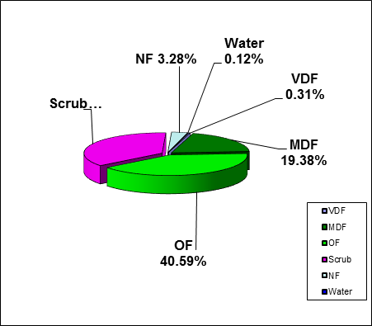
There are 303 VSSs in the Division with 270.90 Km² of forest area, which constitutes 26.65 % of forest area.
Fig 4.16.1
4.16.5 Forest Cover:

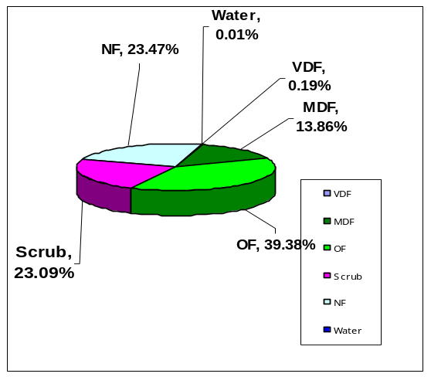
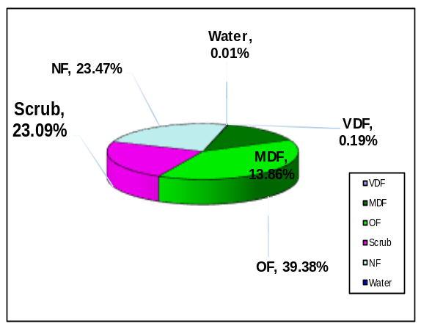The forest cover in the Division based on the interpretation of IRS R2 LISS III 2012 data (Dec / 12/2012) is 610.06 Km² which is 263.13%of geographical area. In terms of forest canopy density classes the Division has 3.16 Km² of Very Dense Forests, 196.09 Km² of Moderately Dense Forests and 410.8154K² of Open Forests. The area of the Scrub is 367.94594.²,Non-Forest 33.212.2827Km² and Water Bodies 1.240.11 The distribution of the forest cover of the Division is shown in Fig 4.16.1.

4.16.6 Change in Forest Cover:
The Satellite images of 2011 and 2012 seasons are shown in Figs. 4.16.2 and 4.16.3 respectively and the changes between this period are shown on the image of 2012.
Comparison of the current forest cover with that of previous assessment year shows a negative change in forest cover of 18.79Ha. The forest cover change matrix given in Table 4.16.2 reveals that there is a decrease of 18.89 Ha of open forest and 93.87 Ha of scrub and increase of 11092 Ha of Non Forest.
The total negative change of 102.07 Ha on ccount of encroachments and the total positive change of 2.43 Ha is on account of raising plantations. Therefore the net loss of forest cover is 10220.01 Ha in the Division.
There are 20 Beats in the Division. Negative changes in Forest Cover are noticed in 11 Beats . There are no changes in the remaining 9 Beats.

Details of forest cover changes in these 11 Beats are shown in Table 4.16.3.

Fig 4.16.2

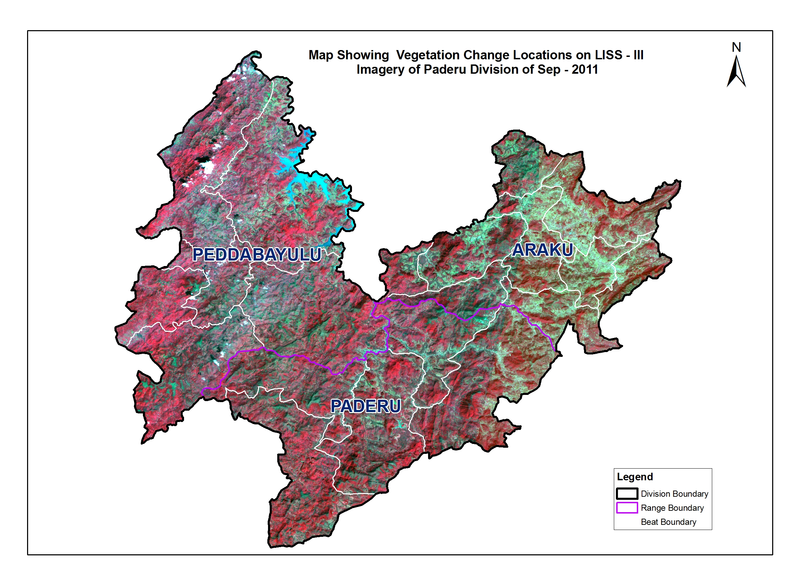

Fig 4.16.3

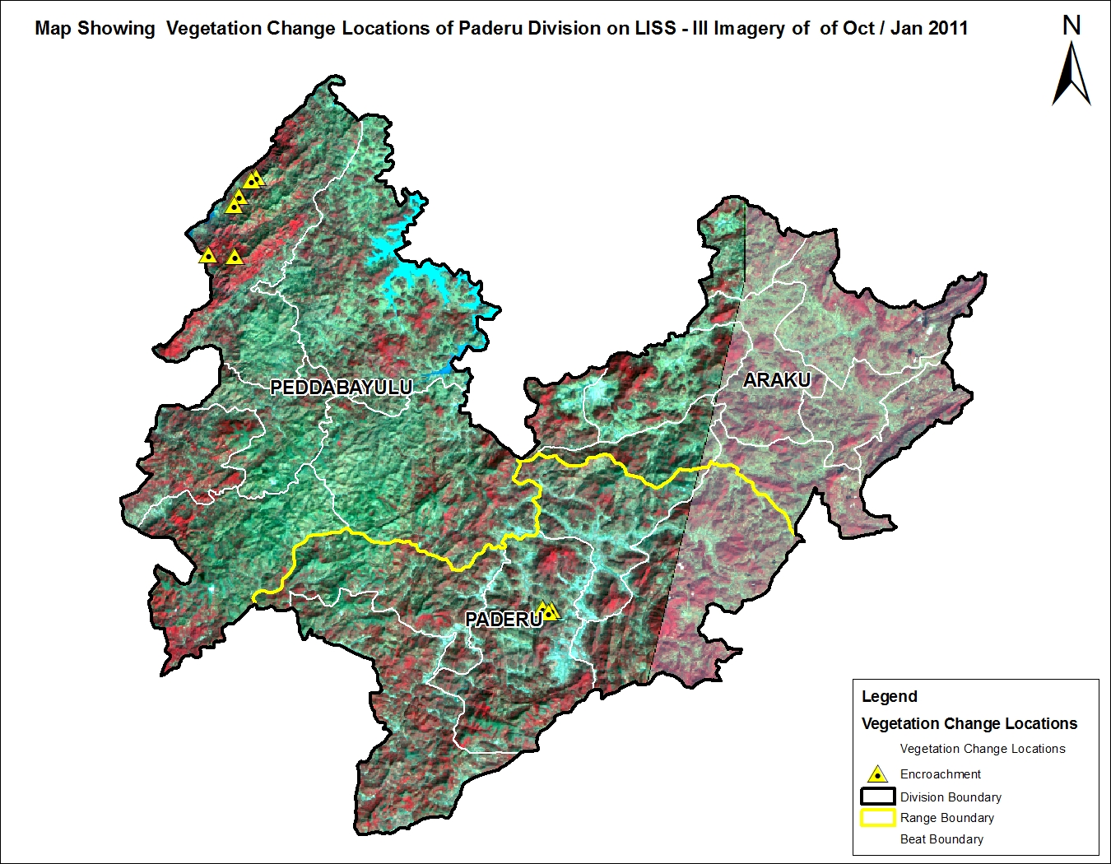
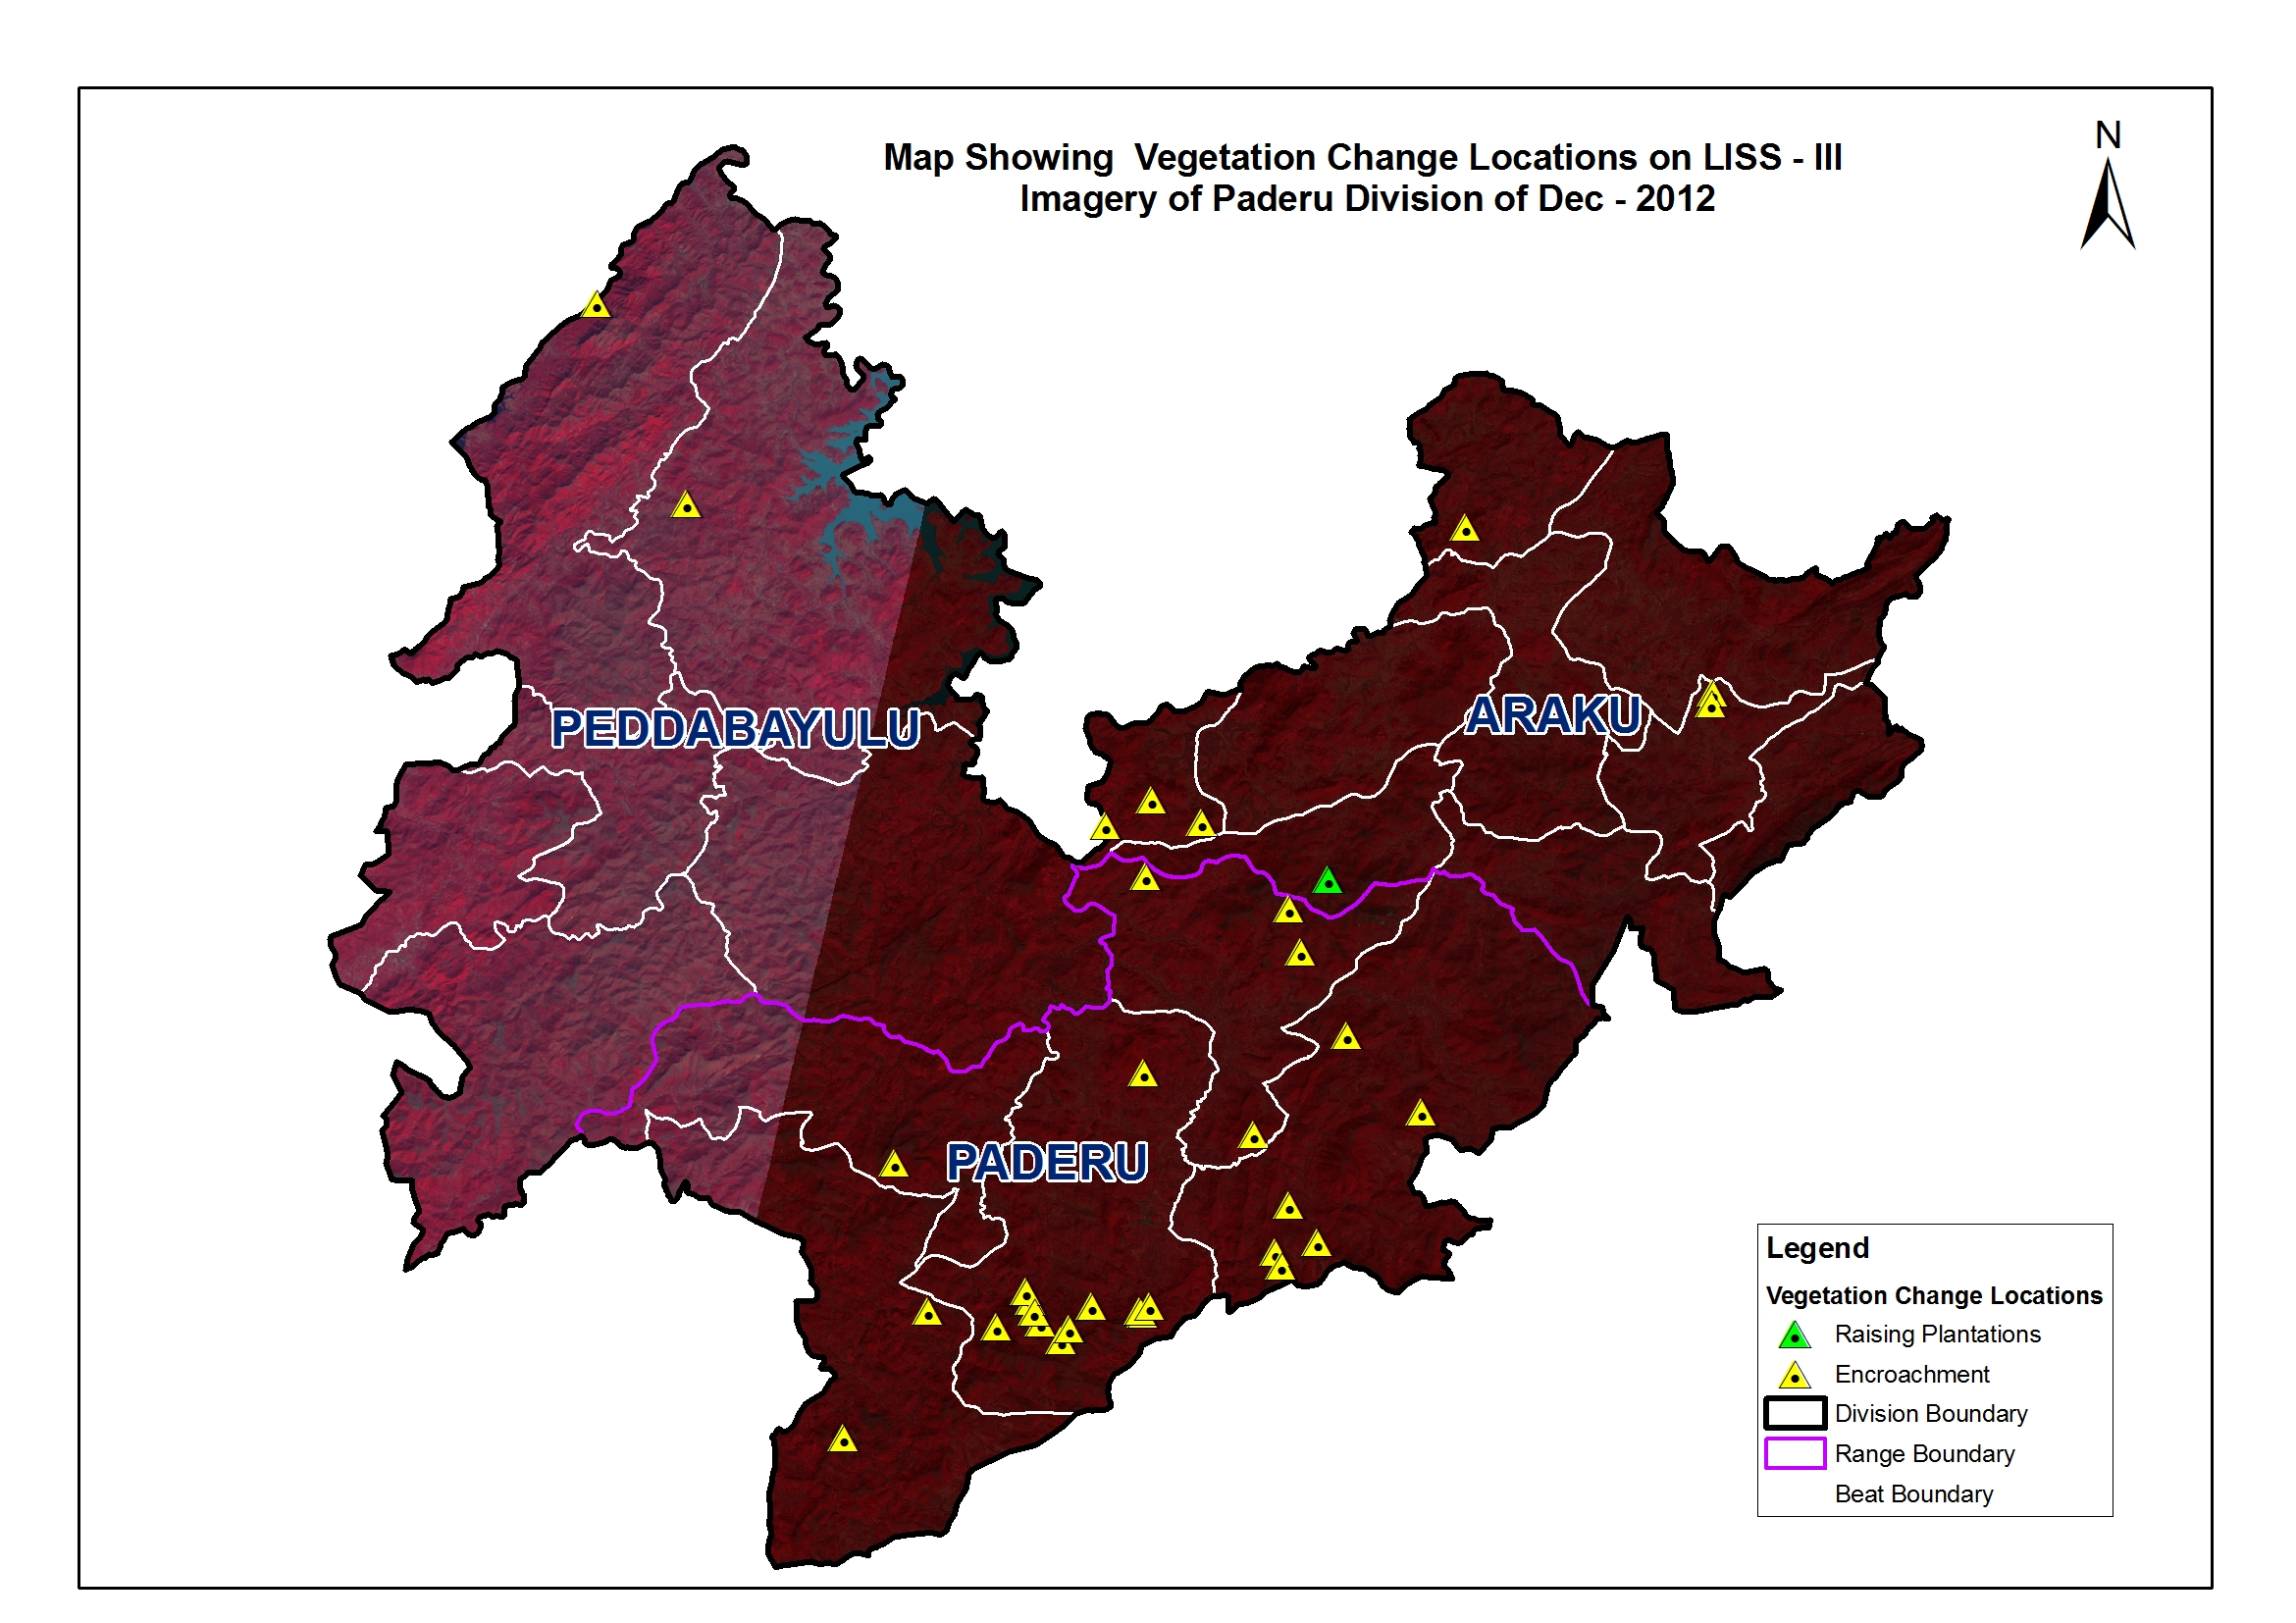

(Area in Km²)

Table 4.16.1: Forest Cover change matrix
2011 | 2012 |  |  |  |  |  | Total of 2011
2011 | VDF | MDF | OF | Scrub | NF | Water | Total of 2011
Very Dense Forest | 3.16 | 0.00 | 0.00 | 0.00 | 0.00 | 0.00 | 3.16
Moderately Dense Forest | 0.00 | 196.09 | 0.00 | 0.00 | 0.00 | 0.00 | 196.09
Open Forest | 0.00 | 0.00 | 410.62 | 0.08 | 0.11 | 0.00 | 410.81
Scrub | 0.00 | 0.00 | 0.00 | 367.10 | 0.84 | 0.00 | 367.94
Non-Forest | 0.00 | 0.00 | 0.00 | 0.02 | 32.26 | 0.00 | 32.28
Water | 0.00 | 0.00 | 0.00 | 0.00 | 0.00 | 1.24 | 1.24
Total of 2012 | 3.16 | 196.09 | 410.62 | 367.20 | 33.21 | 1.24 | 1011.52
Net Change | 0.00 | 0.00 | -0.19 | -0.74 | 0.93 | 0.00

(Area in Ha)
Table 4.16.5: List of Beats showing Forest Cover with changeschange in Forest Co
BEAT | VDF | MDF | OF | SF | NF | WB | Total | Encrochment | Net change
ARAKU RANGE
Araku | 0.00 | 308.91 | 1,653.56 | 1,647.43 | 119.71 | 0.00 | 3,729.61 | 0.00 | 0.00
Arama | 0.00 | 150.60 | 1,411.37 | 1,405.60 | 132.80 | 0.00 | 3,100.37 | 0.00 | -2.43
Gasaba | 0.00 | 132.14 | 703.29 | 1,131.96 | 87.35 | 0.00 | 2,054.74 | 2.29 | -2.29
Guntaseema | 0.55 | 518.50 | 1,036.57 | 127.22 | 5.60 | 0.00 | 1,688.43 | 5.60 | -5.60
Kandrum | 0.00 | 677.97 | 2,182.98 | 739.03 | 15.93 | 0.00 | 3,615.91 | 0.00 | 0.00
Madagada | 0.00 | 48.08 | 485.94 | 1,335.44 | 288.47 | 0.00 | 2,157.93 | 2.53 | -2.53
Mulayagalugu | 0.00 | 376.15 | 1,763.18 | 1,736.11 | 88.06 | 0.00 | 3,963.50 | 0.00 | 0.00
Paraseela | 0.00 | 119.58 | 638.07 | 1,088.07 | 154.14 | 0.00 | 1,999.86 | 0.00 | 0.00
Sukarametta | 0.00 | 95.80 | 616.63 | 1,208.71 | 273.27 | 0.00 | 2,194.42 | 0.00 | 0.00
Total | 0.546 | 2427.724 | 10491.58 | 10419.58 | 1165.34 | 0 | 24504.769 | 10.42 | -12.85
PADERU RANGE
Badimela | 2.13 | 934.08 | 3,084.95 | 2,231.28 | 79.76 | 0.00 | 6,332.20 | 2.67 | -2.67
G.Madugula | 17.80 | 2,262.66 | 4,207.81 | 2,049.25 | 60.63 | 0.00 | 8,598.14 | 3.26 | -3.26
Kinchumanda | 0.00 | 453.32 | 2,846.85 | 1,862.83 | 302.16 | 0.00 | 5,465.16 | 45.02 | -45.02
Paderu | 10.86 | 1,517.73 | 4,080.78 | 2,116.31 | 54.62 | 0.00 | 7,780.29 | 14.65 | -14.65
Sukuru | 7.87 | 1,360.91 | 4,364.07 | 3,007.24 | 147.03 | 0.00 | 8,887.14 | 23.70 | -23.70
Total | 38.65 | 6528.696 | 18584.47 | 11266.91 | 644.194 | 0 | 37062.916 | 89.30 | -89.30
PEDDABAYULU RANGE
Aradakota | 5.26 | 1,427.80 | 3,540.31 | 4,584.48 | 351.40 | 0.00 | 9,909.25 | 0.00 | 0.00
Busiput | 42.80 | 1,850.04 | 903.24 | 600.44 | 157.28 | 0.01 | 3,553.82 | 0.00 | 0.00
Ginnelakota | 104.45 | 2,751.47 | 1,993.66 | 3,847.52 | 441.07 | 0.91 | 9,139.08 | 0.00 | 0.00
Machipuram | 115.42 | 2,935.90 | 2,760.37 | 3,209.07 | 395.87 | 116.61 | 9,533.24 | 1.65 | -1.65
Rudakota | 0.60 | 376.68 | 715.47 | 1,635.01 | 144.44 | 5.25 | 2,877.45 | 0.00 | 0.00
Sujanakota | 8.09 | 1,310.09 | 2,072.92 | 1,157.30 | 21.34 | 1.47 | 4,571.20 | 1.36 | -1.36
Total | 276.6 | 10651.97 | 11985.97 | 15033.82 | 1511.4 | 124.3 | 39584.042 | 3.01 | -3.01
GRAND TOTAL | 315.8 | 19608.39 | 41062.02 | 36720.31 | 3320.93 | 124.3 | 101151.73 | 102.73 | -105.16

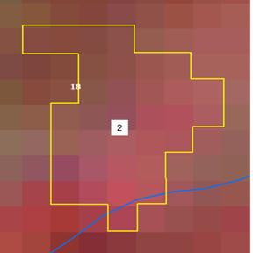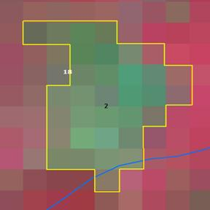

Longitude | 82.91567 ° E
Latitude | 18.30571 ° N
Area in Ha | 1.98
Change | Negative
Comp No. | 18
Beat | Madagada
Range | Araku
Division | Paderu

