4.7 NELLORE DIVISION

4.7.1 Introduction:
Nellore Forest Division comprises of the entire District of Nellore and lies in the south-eastern part of Andhra Pradesh between latitudes 13⁰ 48’ 49.58’’ and 15⁰ 4’ 58.59’’ N and longitudes 79⁰ 6’ 4.36’’ and 80⁰ 14’ 46.71’’ E. Geographical area of the Division is 12934.72 Km².
Land use pattern of the Division is given in Table 4.7.1.

Table 4.7.1: Land use Pattern
Land use | Area in Sq km | Percentage
Forest including Scrub | 1879.83 | 14.53
Agriculture | 6610.72 | 51.11
Land with Scrub | 2126.77 | 16.44
Fallow Lands | 621.88 | 4.81
Grasslands | 21.02 | 0.16
Settlements | 84.33 | 0.65
Vegetation outside Forest | 141.98 | 1.10
Water Bodies | 1448.19 | 11.20
Total | 12934.72
The Division is bordered by the Bay of Bengal on the east, state of Tamil Nadu on the south, the district of Kadapa on the west and the district of Prakasham on the north. The eastern side consists of area of low lying land extending from the base of the Eastern Ghats to the sea. The western side of the district is separated from Kadapa district by Veligonda hills. The district is split by the River Pennar and is located on both south and north banks of it. This Division has 4 physiographic zones - the sea board, the plains, the foothills and the Ghats reaching up to 800 M above MSL. The principal rivers in the district are Pennar in the centre, Kandaleru, Swarnamukhi and Kalinga in the south and Uppuvagu in the north.
The climate of this Division is hot and exhausting for most part of the year. Temperature ranges from 15⁰ to 41⁰ C. Annual rainfall ranges from 700-1040 mm, received from both south-west and north-east monsoons.
The Division is under laid by two types of the oldest rocks, Schistose and Quartzites of the Dharwar System. The Peninsular gneisses, Closepet granite and Pegmatite are also found intruding into the schistose series, the north-west portion of the Dharwarian belt of Nellore is devoid of Pegmatite intrusions but the South Eastern portion, Gudur, Rapur areas are traversed by many intrusions and they contain Deposits of Muscovite mica. The soil types found mainly are Sandy, Red, Lateritic, Murram, Clayey and Alluvial soils.
Population of the Division is 2.96 million (2011 Census), per capita forest area is 0.08 Ha and the population density is 226 persons per Km². The livestock population is 2.5 million.
4.7.2 Recorded Forest Area:
The notified forest area of the Division is 2519.37 Km² which is 19.26% of the geographical area. Reserved, Protected and un-classed forests constitute 2,500.01 Km² (99.23%), 14.46 Km² (0.57%) and 4.90 Km² (0.19%) of the forest area respectively.
As per Champion and Seth’s classification, this Division has 5 major forest types - Dry Red Sanders bearing forest, Southern Tropical Dry Mixed Deciduous forests, Hardwickia binata forest, Southern Tropical Thorn Forest and Southern Topical Dry evergreen forest.

4.7.3 Protected Area:
The Nellore Division is en-compassing 3 Wild Life Sanctuaries namely the Penusila Narasimha Swami (PNS) WLS with an area of 1030 Km², Pulicat Bird Sanctuary (PBS)- a RAMSAR wetland, with an area of 500 Km² and Nelapattu Bird Sanctuary (NBS) with an extent of 4.58 Km².

4.7.4 Community Forest Management:
There are 292 Vana Samrakshana Samities (VSSs) in the Division. An area of 645.93 Km² of forests which is 25.63 % of the notified forests, is under the management of the VSSs.
Fig 4.7.1
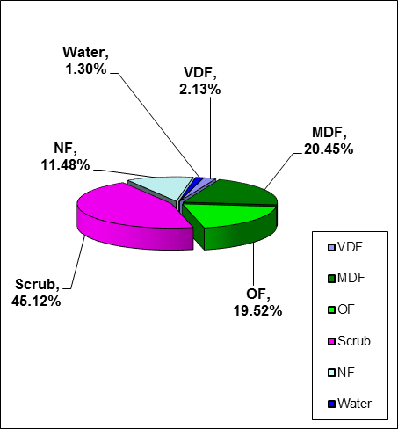
4.7.5 Forest Cover:
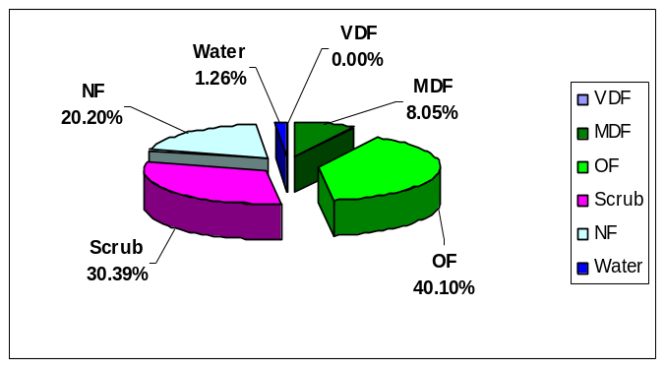
The forest cover in the Division based on the interpretation of IRS R2 LISS III 2012 data (Nov/Dec- 2012) is 1002.12 Km², which is 7.75% of the geographical area. In terms of the forest cover canopy density classes, the Division has 50.80 Km² of very Dense Forest, 486.64 Km² of Moderately Dense Forests and 464.68 Km² of Open Forests. The area of the Scrub is 1073.78 Km², Non-Forest 273.15 Km² and Water Bodies 30.91 Km². The distribution of the forest cover of the Division is shown in Fig 4.7.1

4.7.6 Change in Forest Cover:
The Satellite images of 2011 and 2012 are shown in Figs 4.7.2 & 4.7.3 respectively and the changes between this period, on the image of 2012.
Comparison of the current forest cover with that of previous assessment year shows a negative change of 36.48 Ha. The forest cover change matrix given in Table 4.7.2 reveals that there is a decrease of 36.48 Ha of Open forest. And there is a net change of 269.8 Ha of Scrub forest.

The total positive change (including scrub) is 538.57 Ha. Out of this, 528.39 Ha is on account of growth in raised plantations and 10.18 Ha is on account of improvement of forest due to protection and management interventions. The total negative change (including scrub) is 844.85Ha, in which, 17.40 Ha is on account of encroachments, 13.16 Ha is an account of failure plantations, 194.90 Ha is on account of Harvesting plantation and 619.39 Ha is on account of clearance of jungle growth for raising of plantations. As clearance of jungle growth for raising of plantations and harvesting of matured plantations are forest management interventions, the same are not considered as loss of forest cover. Thus the negative change due to encroachments alone is taken as loss of forest cover. Therefore, the net loss of forest cover is 17.40 Ha in the Division.

Fig 4.7.2

There are 85 Beats in the Division. Negative changes in forest cover are noticed in 18 Beats and positive changes in the forest cover are noticed in 135 eats . There are no changes in the remaining 542 5ats. And there are 2 Beats in Pulicat Bird Sanctuary Range which comes under Wild Life Management Division, Sullurpet.

Details of forest cover along with changes in 85 Beats with changes are shown in Table 4.7.3.
(Area in Km²)

Table 4.7.2: Forest Cover change matrix

2011 |  |  | 2012 |  |  |  |  |  |  |  |  |  |  | Total of 2011
 |  |  |  |  | VDF |  | MDF |  | OF | Scrub |  | NF |  |  | Water
 | Very Dense Forest |  |  |  | 50.80 |  | 0.00 |  | 0.00 | 0.00 |  | 0.00 |  |  | 0.00 | 50.80
 | Moderately Dense Forest |  |  |  | 0.00 |  | 486.64 |  | 0.00 | 0.00 |  | 0.00 |  |  | 0.00 | 486.64
 | Open Forest |  |  |  | 0.00 |  | 0.00 |  | 464.68 | 0.00 |  | 0.36 |  |  | 0.00 | 465.04
 | Scrub |  |  |  | 0.00 |  | 0.00 |  | 0.00 | 1068.39 |  | 8.08 |  |  | 0.00 | 1076.47
 | Non-Forest |  |  |  | 0.00 |  | 0.00 |  | 0.00 | 5.39 |  | 264.71 |  |  | 0.00 | 270.10
 | Water |  |  |  | 0.00 |  | 0.00 |  | 0.00 | 0.00 |  | 0.00 |  |  | 30.91 | 30.91
 | Total of 2012 |  |  |  | 50.80 |  | 486.64 |  | 464.68 | 1073.78 |  | 273.15 |  |  | 30.91 | 2379.96
 | Net Change |  |  |  | 0.00 |  | 0.00 |  | -0.36 | -2.69 |  | 3.05 |  |  | 0.00

Table 4.7.3: List of Beats showing Forest Cover with changes.
(Area in Ha)
BEAT | VDF | MDF | OF | SF | NF | WB | Total
ATMAKUR RANGE
Bata | 7.67 | 923.89 | 977.73 | 1951.08 | 35.02 | 3.22 | 3898.62
Bommavaram | 0.00 | 564.39 | 360.61 | 126.63 | 0.00 | 0.00 | 1051.62
Brahmanapalli | 68.89 | 1219.74 | 479.30 | 408.88 | 20.38 | 5.17 | 2202.36
Gowravaram | 24.93 | 1072.35 | 951.23 | 1352.79 | 8.65 | 2.79 | 3412.73
Gudigunta | 257.98 | 2846.42 | 1325.60 | 1342.97 | 84.26 | 3.13 | 5860.36
Gudipadu | 0.00 | 0.00 | 26.63 | 1122.72 | 756.01 | 193.40 | 2098.75
K.n. palli n | 23.20 | 1448.24 | 871.53 | 295.49 | 1.05 | 0.00 | 2639.51
Kampasamudram | 0.00 | 0.00 | 0.00 | 610.26 | 153.26 | 7.61 | 771.13
Ponguru | 3.65 | 289.09 | 1442.45 | 2384.77 | 59.72 | 0.00 | 4179.68
Rajavolu | 0.00 | 66.84 | 201.27 | 1554.72 | 73.52 | 0.00 | 1896.34
Rajupalem | 34.57 | 1433.23 | 549.74 | 414.32 | 24.62 | 0.00 | 2456.47
Sangam | 26.79 | 194.69 | 648.61 | 1327.50 | 860.29 | 0.00 | 3057.87
Singanapalli | 3.35 | 800.19 | 1057.34 | 1043.34 | 92.80 | 0.00 | 2997.01
T. Talupur | 71.34 | 1950.25 | 833.86 | 617.19 | 26.85 | 0.00 | 3499.49
Venkatapuram | 0.00 | 0.00 | 1179.06 | 2588.27 | 76.11 | 0.00 | 3843.44
Total | 522.37 | 12809.31 | 10904.94 | 17140.91 | 2272.52 | 215.32 | 43865.35
KAVALI RANGE
Bitragunta | 0.00 | 0.00 | 75.16 | 509.33 | 345.64 | 0.00 | 930.13
Chinnannaluru | 0.00 | 0.00 | 1.70 | 1128.60 | 696.15 | 224.43 | 2050.87
Dagadarthi | 4.68 | 60.49 | 901.84 | 1550.06 | 646.64 | 0.00 | 3163.70
Gollapalem | 0.00 | 48.77 | 643.23 | 357.02 | 683.44 | 0.00 | 1732.46
Kavali | 0.00 | 0.00 | 198.34 | 1050.97 | 1368.72 | 8.00 | 2626.03
Kesawaram | 0.00 | 0.73 | 0.00 | 886.65 | 468.30 | 191.22 | 1546.90
Kothapalli | 11.51 | 50.31 | 185.87 | 1451.76 | 475.80 | 19.48 | 2194.72
Racherlapadu | 0.00 | 7.09 | 325.47 | 376.14 | 592.69 | 0.00 | 1301.40
Total | 16.19 | 167.38 | 2331.60 | 7310.54 | 5277.38 | 443.13 | 15546.21
NELLORE RANGE
Dontali | 0.00 | 0.87 | 392.66 | 641.65 | 248.06 | 0.00 | 1283.24
Gudur | 12.97 | 284.14 | 1074.61 | 1209.91 | 358.63 | 0.00 | 2940.27
I puru | 0.00 | 0.00 | 107.51 | 54.64 | 53.92 | 0.00 | 216.08
Kadivedu | 0.00 | 2.18 | 828.64 | 630.24 | 445.48 | 0.00 | 1906.54
Kondlapudi | 0.00 | 0.00 | 347.05 | 742.83 | 612.42 | 3.24 | 1705.54
Kothapatnam | 0.00 | 0.69 | 99.13 | 299.07 | 393.17 | 3.96 | 796.01
Marupur | 1.70 | 153.87 | 980.29 | 1140.13 | 203.21 | 0.00 | 2479.19
Tammenapatnam | 0.00 | 0.00 | 81.41 | 133.94 | 196.30 | 0.00 | 411.66
Teegapalem | 0.00 | 0.00 | 94.41 | 131.99 | 180.48 | 0.00 | 406.88
Vadlapudi | 0.00 | 77.95 | 819.36 | 2079.01 | 994.87 | 0.00 | 3971.20
Varagali | 0.00 | 0.00 | 120.50 | 234.77 | 290.38 | 0.00 | 645.65
Venkatachalam | 0.00 | 17.56 | 974.63 | 1288.84 | 810.32 | 3.64 | 3094.99
Total | 14.67 | 537.26 | 5920.21 | 8587.03 | 4787.24 | 10.83 | 19857.23
PULICAT BIRD SANCTUARY RANGE |  |  |  |  |  |  | 0.00
Pernadu | 0.00 | 3.37 | 690.62 | 162.30 | 299.03 | 0.00 | 1155.32
Venadu | 0.00 | 0.00 | 92.80 | 60.84 | 256.54 | 0.00 | 410.17
Total | 0.00 | 3.37 | 783.42 | 223.14 | 555.57 | 0.00 | 1565.49
RAPUR RANGE |  |  |  |  |  |  | 0.00
Adurpalli | 0.00 | 42.68 | 254.09 | 1098.60 | 60.36 | 0.00 | 1455.73
Ammavaripalem | 9.32 | 191.73 | 406.11 | 1364.57 | 60.63 | 0.00 | 2032.36
Chipini | 213.36 | 1722.76 | 635.89 | 377.59 | 53.98 | 0.00 | 3003.58
Epuru | 180.12 | 1417.70 | 379.45 | 516.14 | 23.77 | 0.00 | 2517.19
Gonupalli | 222.24 | 4574.85 | 1356.86 | 931.80 | 134.74 | 0.00 | 7220.48
Kaluvoya | 136.24 | 1263.90 | 690.56 | 932.30 | 169.56 | 2.87 | 3195.44
Koturupalli | 68.32 | 1572.74 | 641.06 | 413.81 | 113.68 | 0.00 | 2809.61
Penubarthi | 16.83 | 609.17 | 954.68 | 942.26 | 146.86 | 582.30 | 3252.10
Pulikollu | 0.00 | 34.62 | 141.15 | 476.44 | 144.86 | 560.13 | 1357.19
Rajupalem | 28.04 | 1703.89 | 824.55 | 906.78 | 73.98 | 0.00 | 3537.24
Rapur | 349.51 | 2625.48 | 663.05 | 331.24 | 5.33 | 0.00 | 3974.62
Tagecherla | 13.73 | 1359.20 | 554.32 | 437.00 | 32.29 | 0.00 | 2396.55
Thumaya | 0.00 | 178.29 | 678.06 | 851.76 | 169.05 | 734.46 | 2611.62
Turpukambampadu | 0.52 | 43.73 | 354.52 | 1208.40 | 53.57 | 0.00 | 1660.74
Valasa | 215.48 | 1861.98 | 522.80 | 962.49 | 1.24 | 0.00 | 3563.99
Vavintaparthi | 1.27 | 343.80 | 642.86 | 925.91 | 312.71 | 127.58 | 2354.14
Total | 1454.99 | 19546.53 | 9699.99 | 12677.10 | 1556.62 | 2007.34 | 46942.56
UDAYAGIRI RANGE |  |  |  |  |  |  | 0.00
Arlapadia | 0.00 | 2.31 | 945.27 | 7052.29 | 155.94 | 64.67 | 8220.47
Chinnanagampalle | 0.00 | 0.00 | 100.60 | 1769.63 | 51.30 | 0.00 | 1921.52
Devammacheruvu | 0.00 | 0.00 | 2369.75 | 5491.14 | 6.38 | 0.00 | 7867.26
Duttalur | 0.00 | 0.00 | 6.09 | 3162.78 | 587.15 | 132.54 | 3888.55
Kottapalli | 0.00 | 0.00 | 471.31 | 4304.97 | 97.70 | 4.27 | 4878.25
Nandipadu | 0.00 | 0.00 | 67.99 | 2912.90 | 472.71 | 67.08 | 3520.68
Pandrangi | 0.00 | 0.00 | 922.38 | 3938.48 | 4.79 | 0.00 | 4865.65
Sekunalapalli | 0.00 | 0.00 | 122.09 | 3234.00 | 36.45 | 1.06 | 3393.61
Sitatampuram | 0.00 | 0.00 | 248.12 | 2061.05 | 0.00 | 0.00 | 2309.17
Udayagiri (west) | 0.00 | 0.00 | 214.05 | 2110.20 | 91.31 | 11.67 | 2427.23
Udayagiri west | 0.00 | 4.12 | 1115.78 | 1457.89 | 3.36 | 0.00 | 2581.15
Varikuntapadu | 0.00 | 0.69 | 40.21 | 2887.64 | 393.25 | 4.97 | 3326.75
Total | 0.00 | 7.12 | 6623.62 | 40382.96 | 1900.34 | 286.25 | 49200.30
VENKATAGIRI RANGE |  |  |  |  |  |  | 0.00
Alturpad | 574.69 | 3954.10 | 829.24 | 1057.54 | 136.27 | 6.50 | 6558.35
Attiwaram | 0.00 | 0.37 | 166.39 | 802.70 | 1216.53 | 0.00 | 2185.99
Balayapalli | 21.20 | 118.82 | 167.61 | 2651.34 | 1229.18 | 0.94 | 4189.09
Chaganam | 4.34 | 1337.62 | 1641.60 | 1553.90 | 71.85 | 0.00 | 4609.30
Chilamanur | 7.69 | 81.84 | 210.70 | 1497.97 | 532.81 | 60.80 | 2391.81
Chilamuru | 0.00 | 12.89 | 1261.53 | 1728.54 | 2505.12 | 12.40 | 5520.48
Dachuru | 271.94 | 1057.93 | 342.22 | 184.02 | 10.19 | 0.00 | 1866.30
Dakkili | 67.44 | 192.17 | 268.25 | 1647.12 | 417.02 | 0.00 | 2592.00
Davulapalli | 439.18 | 2349.53 | 501.24 | 615.83 | 53.85 | 0.00 | 3959.63
Doravari satram | 0.00 | 0.00 | 397.33 | 949.52 | 1436.76 | 0.00 | 2783.61
Gilakapadu | 6.69 | 1114.57 | 720.15 | 806.90 | 59.74 | 0.00 | 2708.05
Jayampu | 33.79 | 63.47 | 301.02 | 1340.33 | 916.25 | 38.99 | 2693.86
Jorepalli | 8.83 | 224.88 | 615.07 | 1521.68 | 246.94 | 0.00 | 2617.40
Kurjagunta | 194.19 | 1240.97 | 627.58 | 1130.21 | 101.14 | 0.00 | 3294.08
Marlapudi | 0.00 | 0.00 | 41.15 | 26.18 | 46.95 | 0.00 | 114.28
Naidupeta | 0.00 | 0.00 | 113.48 | 554.33 | 604.68 | 0.00 | 1272.50
Palem kota | 828.79 | 1509.85 | 396.77 | 280.68 | 52.64 | 0.00 | 3068.72
Sullurupet | 0.00 | 0.00 | 0.00 | 0.49 | 3.56 | 0.00 | 4.05
Teelthampadu | 473.97 | 808.25 | 193.65 | 238.51 | 12.70 | 0.00 | 1727.08
Uggumudi | 0.00 | 22.72 | 797.83 | 1189.89 | 923.41 | 0.00 | 2933.85
Vembulur | 111.00 | 1339.66 | 295.50 | 416.16 | 124.78 | 0.00 | 2287.10
Yatalur | 28.06 | 162.98 | 315.78 | 861.87 | 264.45 | 8.04 | 1641.17
Total | 3071.82 | 15592.61 | 10204.08 | 21055.69 | 10966.81 | 127.68 | 61018.69
Grand Total | 5080.02 | 48663.57 | 46467.86 | 107377.36 | 27316.47 | 3090.55 | 237995.83

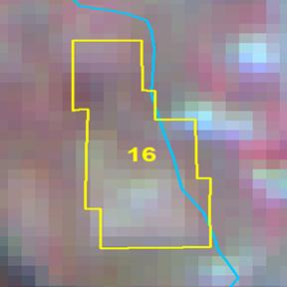
2011 2012

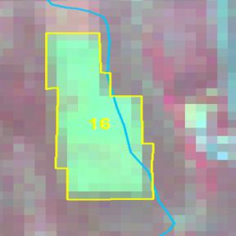

Longitude | 79.99545 ° E
Latitude | 14.80265 ° N
Area in Ha | 8.61
Change | Negative
Comp No. | 26
Beat | Bitragunta
Range | Kavali
Division | Nellore

