4.15. NARSIPATNAM DIVISION

4.15.1 Introduction:
Narsipatnam Forest Division lies in the north-eastern part of Andhra Pradesh between latitudes 17⁰ 27’ 33” and 18⁰ 07’ 02” N and longitudes 81⁰ 51’47” and 82⁰ 47’ 59” E. Geographical area of the Division is 3754.99 Km² which is 30.95% of the geographical area of the district .The Division has two physiographic zones- the plains and the hills. Climate of the Division is characterized by high humidity nearly all round the year with oppressive summer and good seasonal rainfall. The climate of the hill parts of the district is different from that of the plain. Altitude varies from 130 M to 1529 M above MSL. The major rivers falling in the Division are Sileru- a tributary of Godavari, Varaha and Thandava which drain into Bay of Bengal.
Land use pattern of the Division is given in Table 4.15.1.
The climate of the Division is characterized by three distinct seasons. i) Summer (ii) Rainy and (iii)Winter seasons. The temperature ranges from 5⁰ C to 45⁰ C and annual rainfall is about 712mm, received mainly from Southwest monsoons.
The Divisions geology comprises of oldest formation of charnokite series and predominant khondalite group of rocks of Precambrian age. The rocks are essentially Khondalite group with a few charnokite, bands, granites, quartzites, calcigranulites and pegmatites. The chief mineral found is bauxite in all the high hills of the agency area; wherever grasslands exist. There are 3 soil types in the Division - sandy soils of khondalites and quartzites, clayey sands of charnokites and granites and coastal sand dunes of quartzites.
Population of the Division is 0.51 million (2011 Census), per capita forest is 0.46 Ha and the population density is 121 persons per Km².
4.15.2 Recorded Forest Area.
The Notified forest area of the Division is 2353.72 Km² which is 62.67% of the geographical area. Reserved, Protected and un-classed forests constitute 989.92 Km² (42.12%), 1356.31 Km² (57.71%) and 4.05 Km² (0.17%) of the forest area respectively.
As per Champion and Seth’s classification, the Division has Tropical Semi Evergreen Forests, Tropical Secondary Moist Mixed Deciduous Forests, Tropical Dry Deciduous Forests, Tropical Dry Evergreen Scrub, Tropical Thorn Forests and Dry Savanna Forests.
Table 4.15.1: Land use Pattern
Land use | Area in Sq Km | Percentage
Forest including Scrub | 2119.19 | 56.44
Agriculture | 918.52 | 24.46
Land with Scrub | 249.05 | 6.63
Fallow Lands | 22.23 | 0.59
Grasslands | 0.13 | 0
Settlements | 8.5 | 0.23
Vegetation outside Forest | 381.07 | 10.15
Water bodies | 56.3 | 1.5
Total | 3755.00

4.15.3 Protected Area:
There is no Protected Area in this Division.

4.15.4 Community Forest Management:
There are 284 Vana Samrakshana Samities (VSSs) in the Division with an area of 231.13 Km² of forests, which constitutes 9.8% of the forest area.
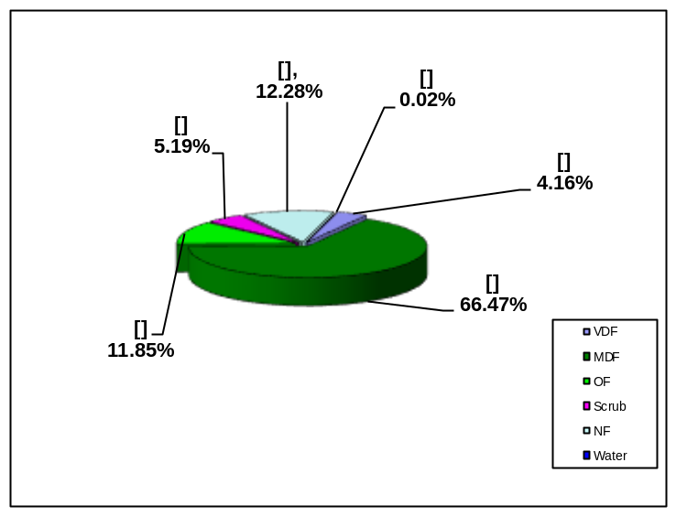
Fig 4.15.1

4.15.5 Forest Cover:

The forest cover in the Division based on the interpretation of IRS R2 LISS III 2012 (Data of Oct/Dec 2012) is 1941.88 Km² which is 51.71 % of the geographical area. In terms of the forest canopy density classes the Division has 98.15 Km² of Very Dense Forests, 1564.66 Km² of Moderately Dense Forests and 279.07. Km² of Open Forests. The area under Scrub is 121.219.96 Km², Non-Forest 289.3036Km² and Water Bodies 0.55 Km². The distribution of the forest cover of the Division is shown in Fig 4.15.1.

4.15.6 Change in Forest Cover:
The satellite image of 2011 and 2012 seasons are shown in Figs. 4.15.2 and Fig 4.15.3 respectively and the changes between this periods are shown on the image of 2012.
Comparison of the current forest cover with that of previous assessment year shows a negative change in forest cover of 5.64 Ha and a positive change in the forest cover of 18.94 Ha. The forest cover change matrix given in Table 4.15.2 reveals that there is an increase of 13.30 Ha of open forest and a446crease of 39.564Ha of scrub.

The total positive change (including scrub) is 21.31 Ha. Out of this, 1.24 Ha is on the account of improvement of encroachment, 16.74 Ha is on account of improvement of forest due to protection and management intervention and 3.33 Ha is on account of growth of raised plantations. The total negative change (including scrub) is 29.6216a. Out of this7.168 a is on account of clearance of jungle growth for raising of plantations and 22.468 a is on account of encroachments. As raising of plantations is a forest management intervention, the same is not considered as loss of forest cover. Thus ohe negative change due to encroachments only isitaken as loss of forest cover. Therefore, the net loss of forest cover is 22.468 a in the Division.

Fig 4.15.2

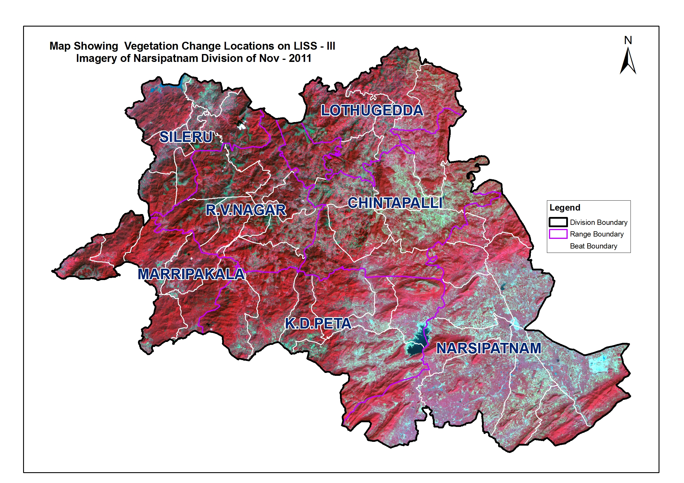

Fig 4.15.3

There are 52 Beats in the Division. Negative changes in forest cover are noticed in 8 Beats and Positive changes in forest cover are noticed in 6 Beats. There are no changes in the remaining 38 Beats.

Details of forest cover changes in the 14 Beats along with other Beats mentioned above are shown in Table 4.15.3.

(Area in Km²)

Table 4.15.2: Forest Cover change matrix
2011 | 2012 |  |  |  |  |  | Total of 2011
2011 | VDF | MDF | OF | Scrub | NF | Water | Total of 2011
Very Dense Forest | 98.15 | 0.00 | 0.00 | 0.00 | 0.00 | 0.00 | 98.15
Moderately Dense Forest | 0.00 | 1564.66 | 0.00 | 0.00 | 0.00 | 0.00 | 1564.66
Open Forest | 0.00 | 0.00 | 278.88 | 0.01 | 0.05 | 0.00 | 278.94
Scrub | 0.00 | 0.00 | 0.19 | 121.93 | 0.24 | 0.00 | 122.36
Non-Forest | 0.00 | 0.00 | 0.00 | 0.02 | 289.07 | 0.00 | 289.09
Water | 0.00 | 0.00 | 0.00 | 0.00 | 0.00 | 0.55 | 0.55
Total of 2012 | 98.15 | 1564.66 | 279.07 | 121.96 | 289.36 | 0.55 | 2353.75
Net Change | 0.00 | 0.00 | 0.13 | -0.40 | 0.27 | 0.00

Table 4.15.3: List of Beats showing Forest Cover with changes
(Area in Ha)
Beat | VDF | MDF | OF | SCRUB | NF | WB | Total | ENC | Net Change
CHINTAPALLI RANGE
Chintapalli_North | 2.882 | 1180.208 | 578.751 | 498.313 | 1747.877 | 0 | 4008.031 | 1.86 | -1.86
Chintapalli_South | 123.091 | 3439.778 | 434.469 | 261.983 | 918.169 | 0 | 5177.49 | 0.00 | 0.00
Jerrela | 14.143 | 3325.435 | 542.646 | 179.953 | 701.002 | 0 | 4763.179 | 0.00 | 0.00
Krishnapuram | 67.297 | 3309.167 | 673.278 | 331.594 | 764.508 | 0 | 5145.844 | 5.84 | -5.84
Lammasingi_North | 57.861 | 2483.132 | 427.637 | 245.316 | 622.723 | 0 | 3836.669 | 0.00 | 0.00
Sarabhannapalem | 488.486 | 7262.197 | 556.263 | 298.764 | 736.471 | 0 | 9342.181 | 0.00 | 0.00
Tajangi | 18.159 | 1358.269 | 623.023 | 430.008 | 1037.036 | 0 | 3466.495 | 0.00 | 0.00
Wangasara | 29.312 | 3326.407 | 644.217 | 524.678 | 1919.326 | 0 | 6443.94 | 0.00 | 0.00
Total | 801.231 | 25684.59 | 4480.284 | 2770.609 | 8447.112 | 0 | 42183.83 | 7.70 | -7.70
K.D.PETA RANGE
Balaram | 358.989 | 4375.36 | 498.424 | 141.535 | 452.534 | 0 | 5826.842 | 0.00 | 0.00
Bangarammapeta | 496.12 | 4389.463 | 90.433 | 54.763 | 143.767 | 0 | 5174.546 | 0.00 | 0.00
Golugonda | 1232.632 | 2608.998 | 175.477 | 152.517 | 387.989 | 0 | 4557.613 | 0.00 | 0.00
K.D.Peta | 96.739 | 1641.584 | 85.706 | 15.96 | 46.303 | 0 | 1886.292 | 0.00 | 0.00
Kakarapadu | 81.261 | 2885.23 | 151.887 | 49.68 | 121.54 | 3.361 | 3292.959 | 0.00 | 0.00
Koyyuru | 432.461 | 5217.205 | 330.796 | 147.714 | 265.794 | 0 | 6393.97 | 0.00 | 0.00
Mampa | 477.216 | 5298.521 | 310.667 | 141.989 | 277.145 | 0 | 6505.538 | 0.00 | 0.00
Total | 3175.418 | 26416.36 | 1643.39 | 704.158 | 1695.072 | 3.361 | 33637.76 | 0.00 | 0.00
LOTHUGEDDA RANGE
Akkajangi | 74.483 | 2373.772 | 685.434 | 482.744 | 827.257 | 0 | 4443.69 | 0.00 | 0.00
Balapam | 241.398 | 7134.453 | 991.298 | 398.886 | 1560.406 | 0 | 10326.44 | 2.89 | -2.89
Cherukumpakalu | 14.54 | 2264.27 | 375.078 | 181.24 | 354.892 | 0 | 3190.02 | 1.60 | -1.60
Kokkiraipally | 21.616 | 2392.835 | 689.674 | 295.225 | 612.612 | 0 | 4011.962 | 2.46 | -2.46
Lothugedda | 0 | 794.121 | 272.406 | 169.141 | 445.611 | 0 | 1681.279 | 0.00 | 0.00
Total | 352.037 | 14959.45 | 3013.89 | 1527.236 | 3800.778 | 0 | 23653.39 | 6.95 | -6.95
MARRIPAKALA RANGE
Cheedipalem | 59.797 | 3937.963 | 75.927 | 23.178 | 96.271 | 0 | 4193.136 | 0.00 | 0.00
Doddavaram | 171.783 | 5391.198 | 270.316 | 104.967 | 380.215 | 0 | 6318.479 | 0.00 | 0.00
M.Bheevaram | 206.751 | 3212.431 | 289.093 | 31.363 | 38.327 | 0 | 3777.965 | 0.00 | 0.00
Marripakala | 42.741 | 4922.086 | 565.088 | 120.208 | 319.299 | 0 | 5969.422 | 0.00 | 0.00
Palakajeedi | 593.095 | 5448.82 | 263.661 | 135.659 | 420.437 | 0 | 6861.672 | 0.00 | 0.00
Valugudem | 75.067 | 2886.446 | 572.732 | 297.298 | 411.769 | 0 | 4243.312 | 0.00 | 0.00
Total | 1149.234 | 25798.94 | 2036.817 | 712.673 | 1666.318 | 0 | 31363.99 | 0.00 | 0.00
NARSIPATNAM RANGE
Arlova | 113.501 | 1183.987 | 285.393 | 152.909 | 699.919 | 0 | 2435.709 | 0.00 | 7.09
Downuru | 704.804 | 2877.118 | 94.957 | 56.544 | 67.986 | 0 | 3801.409 | 0.00 | 0.00
K.V.Puram | 0.368 | 602.396 | 682.024 | 481.637 | 302.024 | 0 | 2068.449 | 0.00 | 0.00
Koduru | 28.451 | 1595.765 | 1443.177 | 217.628 | 4.95 | 0.477 | 3290.448 | 0.00 | 0.96
Kondasantha | 486.497 | 1802.999 | 78.629 | 31.465 | 54.422 | 0 | 2454.012 | 0.00 | -2.36
Kotavuratla | 6.933 | 1106.214 | 1643.54 | 798.934 | 54.377 | 0 | 3609.998 | 2.17 | -2.17
Lammasingi_South | 156.515 | 1859.299 | 204.468 | 97.442 | 244.182 | 0 | 2561.906 | 1.01 | 0.23
Narsipatnam | 347.97 | 1972.202 | 367.33 | 259.56 | 1070.603 | 1.349 | 4019.014 | 4.63 | -4.63
Pedimikonda | 66.798 | 1300.418 | 596.916 | 361.304 | 569.625 | 0 | 2895.061 | 0.00 | 2.37
Thadiparthi | 288.929 | 3849.568 | 500.615 | 310.235 | 745.219 | 0 | 5694.566 | 0.00 | 0.00
Vedurupalli | 867.351 | 2540.29 | 119.668 | 27.408 | 74.853 | 0 | 3629.57 | 0.00 | 0.00
Total | 3068.117 | 20690.26 | 6016.717 | 2795.066 | 3888.16 | 1.826 | 36460.14 | 7.81 | 1.49
R.V.NAGAR RANGE
G.Kothaveedhi | 109.614 | 1506.17 | 281.912 | 137.387 | 377.338 | 0 | 2412.421 | 0.00 | 0.00
Gudem | 282.678 | 3163.436 | 362.064 | 190.686 | 564.762 | 0 | 4563.626 | 0.00 | 0.00
Lankapakalu | 52.85 | 5093.713 | 1138.388 | 288.691 | 1037.936 | 0 | 7611.578 | 0.00 | 3.31
Mandapalli | 228.78 | 4211.793 | 495.57 | 235.674 | 762.59 | 0 | 5934.407 | 0.00 | 0.00
Pedavalasa_North | 21.947 | 1804.805 | 383.676 | 214.461 | 632.468 | 0 | 3057.357 | 0.00 | 0.00
Pedavalasa_South | 374.881 | 3817.501 | 382.571 | 206.639 | 421.714 | 0 | 5203.306 | 0.00 | 1.54
R.V.Nagar | 10.528 | 2645.837 | 471.694 | 192.447 | 294.639 | 0 | 3615.145 | 0.00 | 0.00
Sapparla | 50.023 | 4636.083 | 870.803 | 273.473 | 761.477 | 0 | 6591.859 | 0.00 | 0.00
Total | 1131.301 | 26879.34 | 4386.678 | 1739.458 | 4852.924 | 0 | 38989.7 | 0.00 | 4.85
SILERU RANGE
A.Dharakonda | 66.576 | 3311.812 | 878.683 | 375.511 | 1139.977 | 30.372 | 5802.931 | 0.00 | 0.00
Dharakonda | 0 | 1100.909 | 754.158 | 257.451 | 540.131 | 0 | 2652.649 | 0.00 | 0.00
Duppulawada | 1.059 | 808.969 | 773.738 | 407.119 | 1115.852 | 0 | 3106.737 | 0.00 | 0.00
Kondajartha | 54.887 | 2853.203 | 491.447 | 122.816 | 366.961 | 0 | 3889.314 | 0.00 | 0.00
Sadigunta | 2.009 | 1894.055 | 981.382 | 374.427 | 657.834 | 0 | 3909.707 | 0.00 | 0.00
Sileru | 3.116 | 4051.391 | 2060.187 | 313.301 | 467.855 | 19.075 | 6914.925 | 0.00 | 0.00
Thokarai | 9.525 | 2016.506 | 389.947 | 97.13 | 296.017 | 0 | 2809.125 | 0.00 | 0.00
Total | 137.172 | 16036.85 | 6329.542 | 1947.755 | 4584.627 | 49.447 | 29085.39 | 0.00 | 0.00
Division Total | 9814.51 | 156465.8 | 27907.32 | 12196.96 | 28934.99 | 54.634 | 235374.2 | 22.46 | -8.31

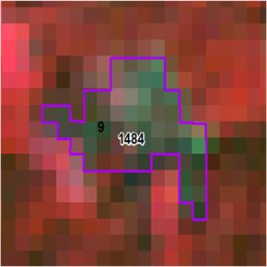
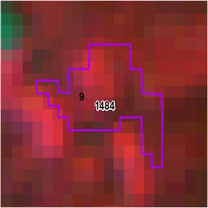

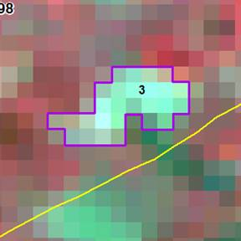
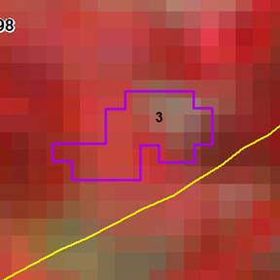

Longitude | 82.51834
Latetude | 17.68290
Area Ha | 11.89
Change | SF to NF
Compt No | 1207
Beat | Arlova
Range | Narsipatnam
Division | Narsipatnam

