4.4 MARKAPUR WLM DIVISION

(Included WLM Nagarjuna Sagar area)

4.4.1 Introduction:
Markapur WLM Forest Division lies in the south-eastern part of Prakasham district between latitudes 15⁰ 23’ 1’’ and 16⁰ 18’ 16’’ N and longitudes 78⁰ 47’ 48’’ and 79⁰ 57’ 56’’ E. Geographical area of the Division is 7,218 Km² which is 25.1 % of the area of the District. The seasonal rivers like Gundlakamma, Sagileru, Musi, Paleru and Manneru flow through the Division. The Gundlakamma river rises in Nallamala hills and the famous Cumbum Tank is formed across this river.
Land use pattern of the Division is given in Table 4.4.1
The climate of this Division is dry and salubrious, temperatures ranging from 19⁰C to 40⁰C; the annual rainfall is about 871 mm, received mainly from Southwest monsoons.
Sandstone mixed with quartzite and occasional shales are the characteristic rock formations on the Veligondas and at their extremes, bordering Kanigiri, the rocks gradually change into Gneisses or Granite composition. Outcrops of Barytes and Manganese ores occur in Veligondas. The soil types found mainly are red loamy, black cotton, sandy loam and sandy.
Population of the Division is 0.86 million (2011 Census), per capita forest area is 0.26 Ha and the population density is 155 persons per Km².

4.4.2 Recorded Forest Area:
The notified forest area of the Division is 2476.39 Km² which is 34.30% of the geographical area. The status of entire forest area is Reserved Forest.
As per Champion and Seth’s classification the forests of Division fall under Southern Tropical dry deciduous, as the predominant and climatic climax forest in the Division. The Southern Tropical Thorn Forest also occurs in low elevations and in plains.
Table 4.4.1: Land use Pattern

Land use* | Area in Sq Km | Percentage
Forest including Scrub | 2014.3 | 27.91
Agriculture | 4267.32 | 59.12
Land with Scrub | 534.29 | 7.40
Fallow Lands | 111.67 | 1.55
Grasslands | 13.84 | 0.19
Settlements | 31.10 | 0.43
Vegetation outside Forest | 188.96 | 2.62
Water bodies | 56.53 | 0.78
Total | 7218.00
*Only the extent of Markapur was shown, Vijayapuri south range details were not included.

4.4.3 Protected Area:
Parts of 2 Protected Areas, viz., the Nagarjuna Sagar Srisailam Tiger Reserve (NSTR) and Gundla Brahmeswaram (GBM) Wild Life Sanctuary, fall in the Division. An area of 1039.51 Km² is included in the Nagarjuna Sagar Srisailam Tiger Reserve and 55.45 Km² in the Gundla Brahmeswaram Wild Life Sanctuary (GBM).

4.4.4 Community Forest Management:
There are 93 Vana Samrakshana Samities (VSSs) in the Division. An area of 347.14 Km² forests, which is 14.01 % of the notified forests, is under the management of VSSs.
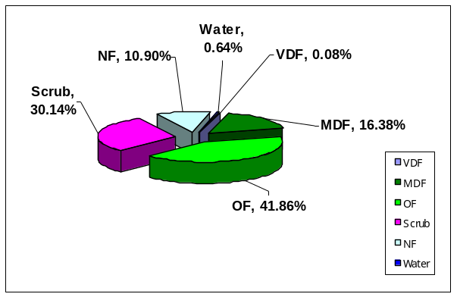
Fig 4.4.1 1

Fig. 4.4.1
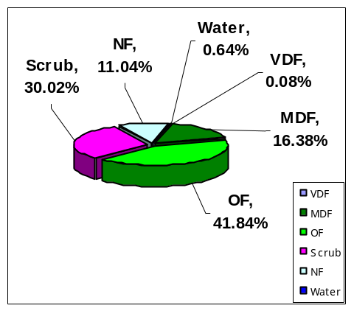
4.4.5 Forest Cover:
The forest cover in the Division based on the interpretation of IRS R2 LISS III 2012 data (Dec-2012) is 1397.38 Km² which is 19.35% of the geographical area. In terms of the forest cover canopy density classes the Division has 7.00 Km² of Very Dense Forests, 207.36 Km² of Moderately Dense Forests and 1183.02 Km² of Open Forests. The area of the Scrub is 1148.03 Km², Non-Forest 49.39 Km² and Water Bodies 25.95 Km². The distribution of the forest cover of the Division is shown in Fig 4.4.1

4.4.6 Change in Forest Cover:
The satellite images of 2011 and 2012 are shown in Fig 4.4.2 & 4.4.3 respectively and the changes between this Period are shown on the image of 2012.
Comparison of the current forest cover with that of previous assessment year shows a negative change of 8.27 Ha. The forest cover change matrix given in Table 4.4.2 reveals that there is a decrease of 8.26 Ha of open forest and increase of 37.66 Ha of scrub.
The total negative change (including scrub) of 138.83 Ha. Out of this 31.00 Ha is on account clearance of jungle growth for raising of plantations and 107.83 Ha is on account of encroachment. Positive change (including scrub) is 36.55168.22 Ha is on account of is an account of growth in raised plantations, As clearance of jungle growth for raising of plantations is a forest management intervention the same is not considered as loss of forest cover. Thus only the negative change on account of encroachments is taken as loss of forest cover. Therefore the net loss of forest cover is 107.83 Ha only.
There are 48 Beats in the Division. Negative changes in forest cover are noticed in 8 Beats and Positive changes in forest cover are 3 Beats. Tthere are no changes in the remaining 372 Beats.
Details of forest cover changes in these 11 Beats and other 372Beats mentioned above are shown in Table 4.4.3.

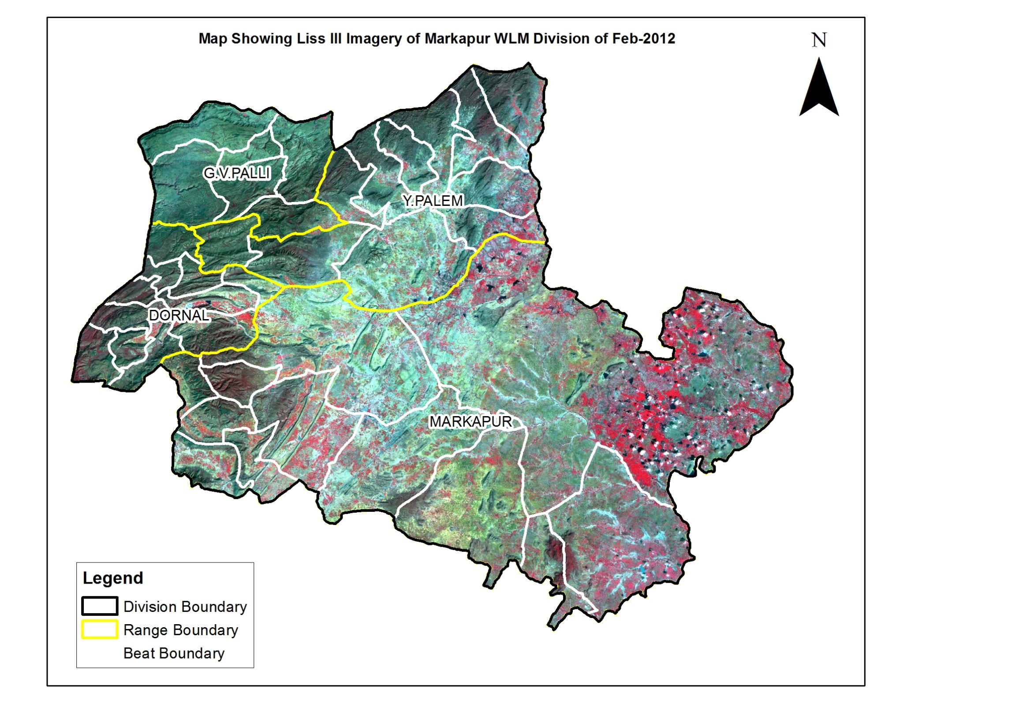
Fig 4.4.2

Fig 4.4.3

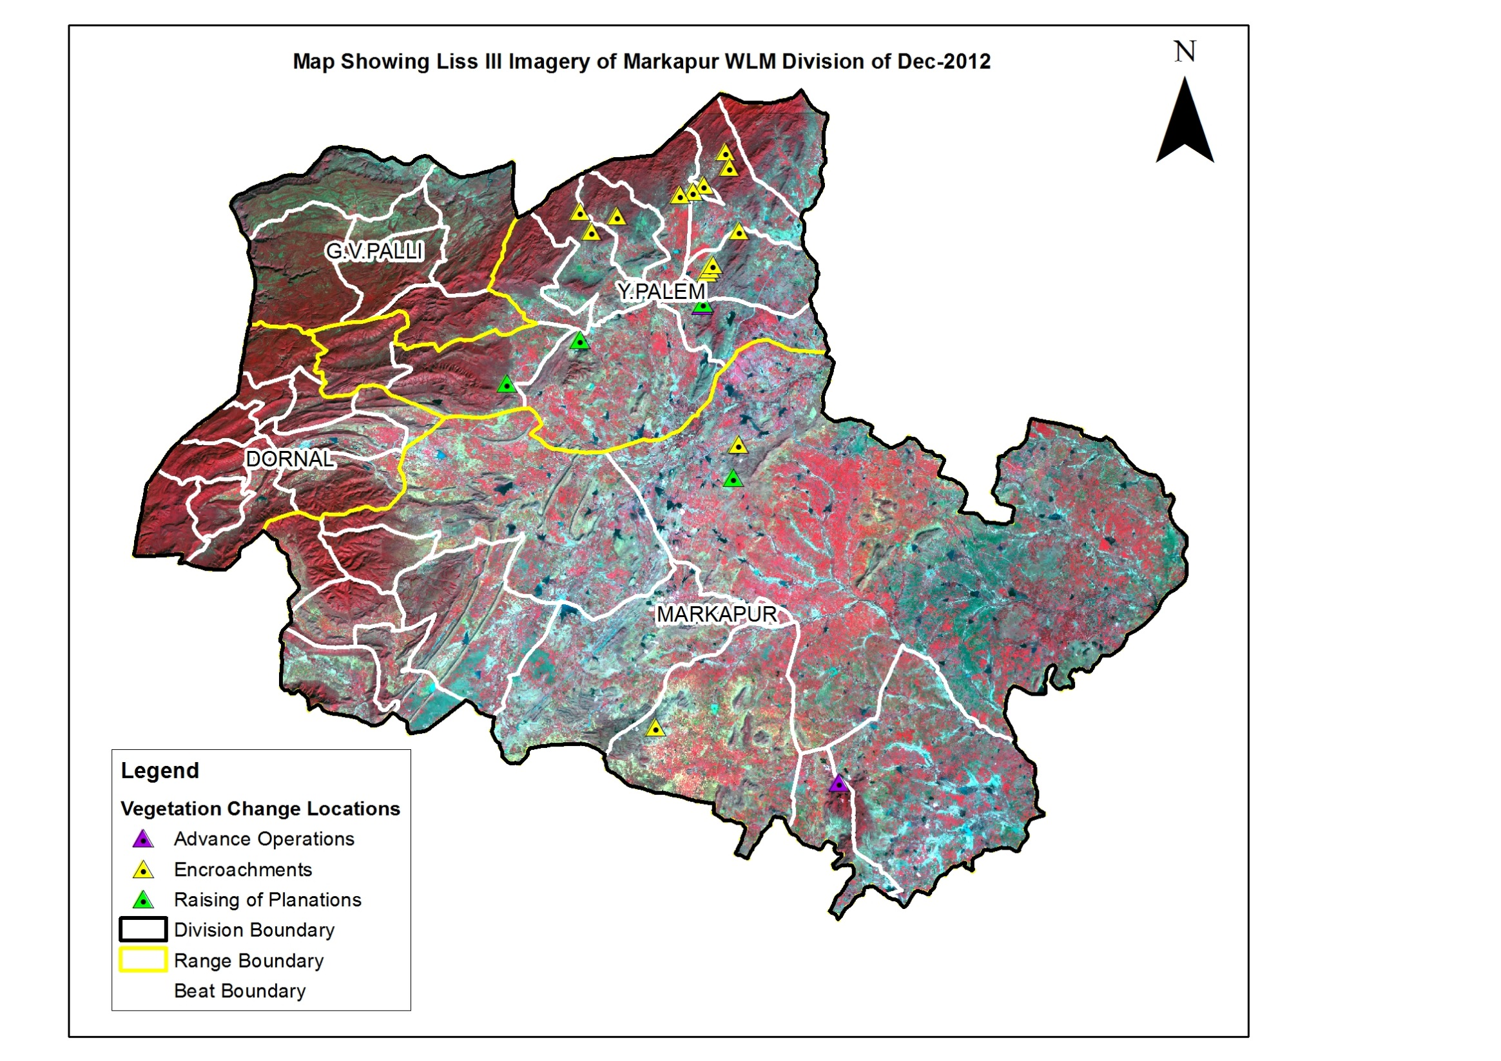

(Area in Km²)

Table 4.4.2: Forest Cover change matrix

2011 | 2012 |  |  |  |  |  | Total of 2011
2011 | VDF | MDF | OF | Scrub | NF | Water | Total of 2011
Very Dense Forest | 7.00 | 0.00 | 0.00 | 0.00 | 0.00 | 0.00 | 7.00
Moderately Dense Forest | 0.00 | 207.36 | 0.00 | 0.00 | 0.00 | 0.00 | 207.36
Open Forest | 0.00 | 0.00 | 1183.02 | 0.00 | 0.08 | 0.00 | 1183.10
Scrub | 0.00 | 0.00 | 0.00 | 1146.35 | 1.31 | 0.00 | 1147.66
Non-Forest | 0.00 | 0.00 | 0.00 | 1.68 | 48.00 | 0.00 | 49.68
Water | 0.00 | 0.00 | 0.00 | 0.00 | 0.00 | 25.95 | 25.95
Total of 2012 | 7.00 | 207.36 | 1183.02 | 1148.03 | 49.39 | 25.95 | 2620.75
Net Change | 0.00 | 0.00 | -0.08 | 0.37 | -0.29 | 0.00

(Area in Ha)

Table 4.4.3: List of Beats showing Forest Cover with changes.
BEAT | VDF | MDF | OF | SF | NF | WB | Total | Net Change | ENC
DORNAL RANGE
Ch.Mantanala | 78.81 | 2112.54 | 3457.55 | 756.98 | 4.44 | 0.00 | 6410.32 | 0.00 | 0.00
Chilakacherla | 12.37 | 1377.36 | 4516.83 | 713.25 | 72.29 | 0.00 | 6692.10 | 0.00 | 0.00
Chinnarutla | 0.00 | 71.63 | 3146.98 | 2252.11 | 2.17 | 0.00 | 5472.89 | 0.00 | 0.00
Chintala | 11.91 | 362.32 | 3027.80 | 482.11 | 0.82 | 0.00 | 3884.97 | 0.00 | 0.00
Edavalli | 0.00 | 297.42 | 1597.24 | 421.78 | 0.00 | 0.00 | 2316.44 | 0.00 | 0.00
Nallaguntla | 3.16 | 342.81 | 2149.31 | 884.97 | 49.18 | 0.00 | 3429.43 | 0.00 | 0.00
P. Bommalapuram | 1.64 | 96.01 | 821.97 | 842.41 | 0.00 | 0.00 | 1762.04 | 0.00 | 0.00
Peddachama | 8.89 | 1065.54 | 1928.59 | 27.58 | 0.00 | 0.00 | 3030.60 | 0.00 | 0.00
Peddamantanala | 6.20 | 1372.28 | 3425.67 | 241.09 | 0.00 | 0.00 | 5045.23 | 0.00 | 0.00
Tummalabailu | 2.29 | 235.49 | 2233.03 | 395.60 | 0.00 | 0.00 | 2866.41 | 0.00 | 0.00
Y.Cherlopalli | 0.00 | 262.37 | 3556.78 | 1306.91 | 15.40 | 6.69 | 5148.15 | 0.00 | 0.00
Total | 125.28 | 7595.78 | 29861.74 | 8324.80 | 144.29 | 6.69 | 46058.57 | 0.00 | 0.00
G.V.PALLI RANGE
G.V.Palli | 11.19 | 252.74 | 5582.42 | 1764.04 | 5.70 | 1.82 | 7617.91 | 0.00 | 0.00
Guttalachenu | 9.89 | 71.38 | 615.22 | 11737.28 | 174.18 | 480.92 | 13088.87 | 0.00 | 0.00
Nekkanti | 8.86 | 107.26 | 1824.90 | 13726.35 | 144.89 | 37.54 | 15849.80 | 0.00 | 0.00
Palutla | 1.55 | 48.34 | 519.94 | 3889.39 | 23.98 | 1.81 | 4485.01 | 0.00 | 0.00
Regumanipenta | 23.38 | 546.74 | 7002.44 | 13142.10 | 55.71 | 221.01 | 20991.37 | 0.00 | 0.00
Total | 54.87 | 1026.47 | 15544.92 | 44259.15 | 404.45 | 743.11 | 62032.97 | 0.00 | 0.00
MARKAPUR RANGE
Bommilingam | 2.56 | 655.46 | 2377.06 | 866.29 | 0.94 | 0.00 | 3902.30 | 0.00 | 0.00
Donkaonda | 0.00 | 96.43 | 2069.04 | 1674.85 | 50.84 | 0.00 | 3891.17 | 0.00 | 0.00
Gotlagattu | 0.00 | 196.03 | 2491.24 | 1169.52 | 241.07 | 0.00 | 4097.87 | -6.69 | 6.69
Gottipadia | 4.62 | 666.32 | 4516.83 | 626.42 | 0.00 | 0.00 | 5814.20 | 0.00 | 0.00
Gundamcherla | 39.06 | 3131.09 | 2856.38 | 76.79 | 0.00 | 0.00 | 6103.32 | 0.00 | 0.00
Kalanuthala | 7.11 | 781.74 | 3416.22 | 1614.43 | 46.72 | 0.00 | 5866.21 | 0.00 | 0.00
Kaluzuvvalapadu | 0.00 | 168.76 | 1855.38 | 1750.46 | 50.96 | 1.94 | 3827.49 | 0.00 | 0.00
Magutur | 12.04 | 607.26 | 3238.82 | 1312.30 | 41.65 | 0.00 | 5212.06 | 0.00 | 0.00
Nagulavaram | 0.00 | 100.90 | 1727.07 | 828.62 | 6.74 | 0.00 | 2663.34 | 0.00 | 0.00
Peddarikatla | 170.65 | 1342.32 | 1211.02 | 296.33 | 32.81 | 0.00 | 3053.13 | -23.14 | 0.00
Podili | 92.39 | 1082.54 | 970.74 | 222.09 | 0.00 | 0.00 | 2367.76 | 0.00 | 0.00
Potlapadu | 49.98 | 245.81 | 1681.84 | 3447.87 | 1496.49 | 21.01 | 6942.98 | 119.63 | 11.49
Total | 378.41 | 9074.66 | 28411.61 | 13885.97 | 1968.22 | 22.95 | 53741.81 | 89.80 | 18.18
V.P.SOUTH RANGE
Gangalgunta | 3.14 | 112.68 | 1602.49 | 3616.53 | 29.11 | 217.50 | 5581.44 | 0.00 | 0.00
Gottipalli | 38.16 | 55.61 | 113.28 | 3019.25 | 157.25 | 364.70 | 3748.24 | 0.00 | 0.00
Kandlgunta | 5.82 | 10.52 | 46.21 | 1591.49 | 154.36 | 0.00 | 1808.40 | 0.00 | 0.00
Koppunuru | 4.92 | 12.07 | 82.55 | 5059.89 | 935.65 | 628.13 | 6723.21 | 0.00 | 0.00
Nagulavaram | 0.00 | 6.69 | 21.40 | 1237.95 | 49.09 | 7.92 | 1323.04 | 0.00 | 0.00
Pasuvemula | 4.53 | 19.44 | 49.95 | 2779.43 | 201.56 | 2.86 | 3057.76 | 0.00 | 0.00
Sirigiripadu | 35.90 | 184.76 | 4526.54 | 2487.05 | 0.77 | 0.00 | 7235.02 | 0.00 | 0.00
Tummurukota | 19.67 | 72.73 | 125.01 | 2564.08 | 202.30 | 0.00 | 2983.80 | 0.00 | 0.00
Zuvuku | 8.42 | 26.14 | 34.83 | 1578.83 | 226.01 | 593.69 | 2467.92 | 0.00 | 0.00
Total | 120.55 | 500.63 | 6602.25 | 23934.50 | 1956.10 | 1814.80 | 34928.82 | 0.00 | 0.00
Y.PALEM RANGE
Akkapalem | 0.00 | 379.05 | 5956.94 | 858.40 | 0.00 | 0.00 | 7194.39 | 0.00 | 0.00
Boyalapalli | 0.00 | 10.05 | 323.46 | 3402.37 | 5.66 | 0.00 | 3741.54 | 3.00 | 0.00
Kolukula | 5.16 | 437.19 | 5995.87 | 3668.03 | 3.81 | 0.00 | 10110.06 | 29.99 | 0.00
Komarolu | 9.97 | 121.35 | 3672.74 | 3041.85 | 39.61 | 0.00 | 6885.53 | -11.61 | 11.61
Mallapalem | 0.00 | 30.70 | 2516.53 | 2084.36 | 261.44 | 0.00 | 4893.02 | -6.44 | 6.44
Naidupalem | 0.00 | 2.09 | 764.41 | 1089.12 | 9.84 | 0.00 | 1865.45 | -3.75 | 0.00
Pullalacheruvu | 0.00 | 754.99 | 3802.34 | 845.07 | 25.38 | 0.00 | 5427.79 | -5.05 | 5.05
Rentapalli | 0.00 | 6.02 | 1014.74 | 2537.65 | 62.95 | 0.00 | 3621.36 | -61.02 | 61.02
T.R.Cheruvu | 5.82 | 126.96 | 4209.61 | 3743.52 | 3.24 | 0.00 | 8089.15 | 0.00 | 0.00
Veerabhadrapuram | 0.00 | 339.04 | 4644.99 | 1235.97 | 3.14 | 7.19 | 6230.33 | 0.00 | 0.00
Venkatareddypalli | 0.00 | 331.11 | 4979.24 | 1893.29 | 50.61 | 0.00 | 7254.25 | -5.53 | 5.53
Total | 20.95 | 2538.55 | 37880.85 | 24399.64 | 465.69 | 7.19 | 65312.86 | -60.41 | 89.65
Grand Total | 700.05 | 20736.08 | 118301.37 | 114804.05 | 4938.75 | 2594.73 | 262075.02 | 29.39 | 107.83
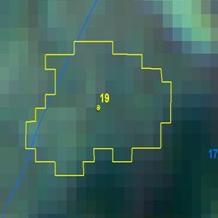
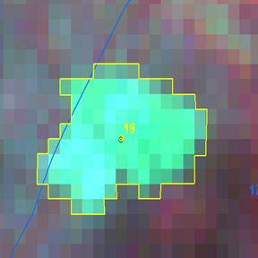

Longitude | 79.30405 ° E
Latitude | 16.14790 ° N
Area in Ha | 6.08
Change | Negative
Comp No. | 174
Beat | Komarolu
Range | Markapur
Division | Markapur

