4.6 GUNTUR DIVISION

4.6.1 Introduction:
Guntur Forest Division comprises of the entire District and lies in the south-eastern part of Prakasham District between latitudes 15⁰ 42’ 13.68’’ and 16⁰ 49’ 23.52’’ N and longitudes 79⁰ 12’ 34.56’’ and 80⁰ 54’ 16.92’’ E. Geographical area of the Division is 10623.19 Km². The Division has four physiographic zones- the sea board, the plains, ghats and hills rising gently to an altitude of 500 M and the ‘U” shaped Nallamalai hills skirting Macherla to its west and Markapur and Kurnool Divisions to the east. The other hill ranges of the Division are Venkatayyapalem and Kondaveedu of Sattenapalli and Narasaraopet. The important rivers draining into the Division are the Krishna and the Gundlakamma with tributaries Chandravanka, Goli and Naguleru in Macherla.
Land use pattern of the Division is given in Table 4.6.1
Table 4.6.1: Land use Pattern
The climate of this Division is dry and salubrious; temperature ranges from 17⁰C to 40⁰C and the annual rainfall is about 989 mm received both from the South-West and North-East monsoons.
Land use | Area in Sq Km | Percentage
Forest including Scrub | 1112.92 | 10.48
Agriculture | 8446.28 | 79.51
Land with Scrub | 80.08 | 0.75
Fallow Lands | 314.65 | 2.96
Grasslands | 0.71 | 0.01
Settlements | 287.41 | 2.71
Vegetation outside Forest | 107.88 | 1.02
Water Bodies | 273.26 | 2.57
Total | 10623.19
The Common rocks are Shales, Slates, Lime-stone, Quartzite, Gneisses and Schist. Soils of all kinds occur in the Division, Swampy in the Krishna estuary, Sandy along the coast, Alluvial on the banks of Krishna, Red Gravelly in the interior and Loamy of rather rare occurrence.
Population of Guntur Division is 4.88 million (2011 Census); the per capita forest area is 0.04 Ha and the population density is 429 persons per Km². The livestock population is 2.3 million.

4.6.2 Recorded Forest Area:
The notified forest area of the Division is 1411.10 Km², which is 13.28 % of the geographical area. The entire forest area is Reserved Forest.
As per Champion and Seth’s classification, the major Forest types of Division are Coastal Forests and Inland Forests. In Coastal Forests, Mangroves and Dry evergreen Forests are present. Whereas, Inland Forests contains Southern Dry Mixed Deciduous, Hardwickia binata and Acacia arabica forests.
4.6.3 Protected Area:
The Division contains a part of the Krishna Wildlife Sanctuary (KWS). An area of 81.99 Km² of the Division is included in the Krishna Wildlife Sanctuary (KWS).
4.6.4 Community Forest Management:
There are 180 Vana Samrakshana Samities (VSSs) in the Division. An area of 260.80 Km² forests, which constitutes 16.10 % of the notified forests, is under the management of the VSSs.
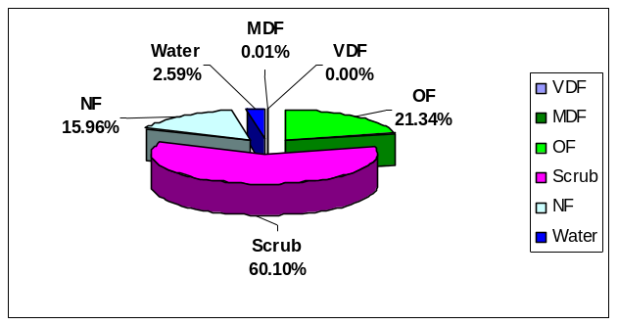

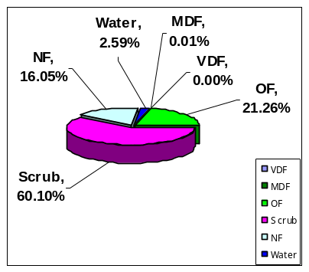
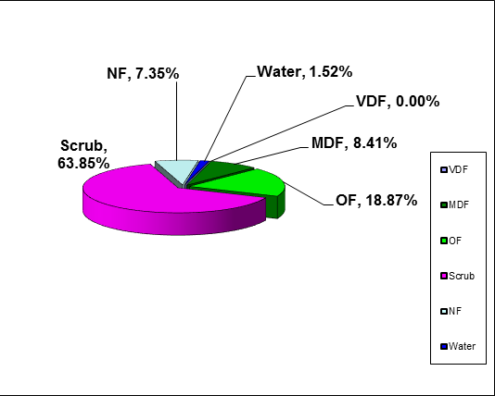
4.6.5 Forest Cover:
Fig 4.6.1
The forest cover in the Division based on the interpretation of IRS R2 LISS III 2012 data (Nov 2012) is 402.95 Km² which is 3.79% of the Geographical area. In terms of the forest canopy cover density classes, the Division has 124.24 Km² of Moderately Dense Forests and 278.71 Km² of Open Forests. The area of the Scrub is 942.96 Km², Non-Forest 108.50 Km² and Water Bodies 22.50 Km². The distribution of the forest cover of the Division is shown in Fig 4.6.1.

4.6.6 Change in Forest Cover:
The satellite images of 2011 and 2012 are shown in Figs 4.6.2 & 4.6.3 respectively. The changes between this period are shown on the image of 2012.
Comparison of the current forest cover with that of previous assessment year shows a negative change of 10.84 Ha. The forest cover change matrix given in Table 4.6.2 reveals that there is a decrease of 10.84 Ha of open forest and 185.11 Ha of scrub with a total increase of 195.95 Ha of Non Forest.
Out of the total negative change of 195.95 Ha, 174.86 Ha is on account of clearance of jungle growth for raising of plantations and 13.11 Ha on account of encroachments and 7.98 Ha is on account of Fire. As clearance of jungle growth for raising of plantations is forest management intervention, the same is not considered as loss of forest cover. Loss of forest cover due to fire is also not considered as loss of forest cover as it is temporary loss only. Thus the negative change due to encroachments alone is taken as loss of forest cover. Therefore, the net loss of forest cover is 10.84 Ha only.

Fig 4.6.2
Fig 4.6.3

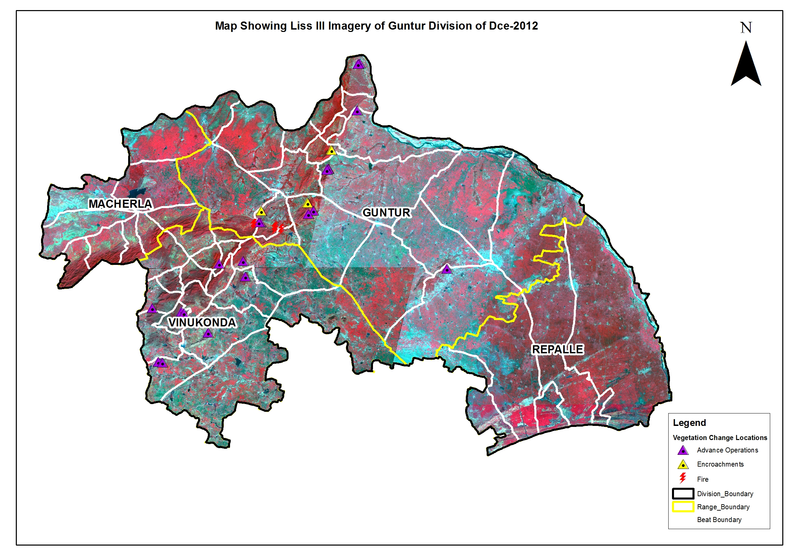
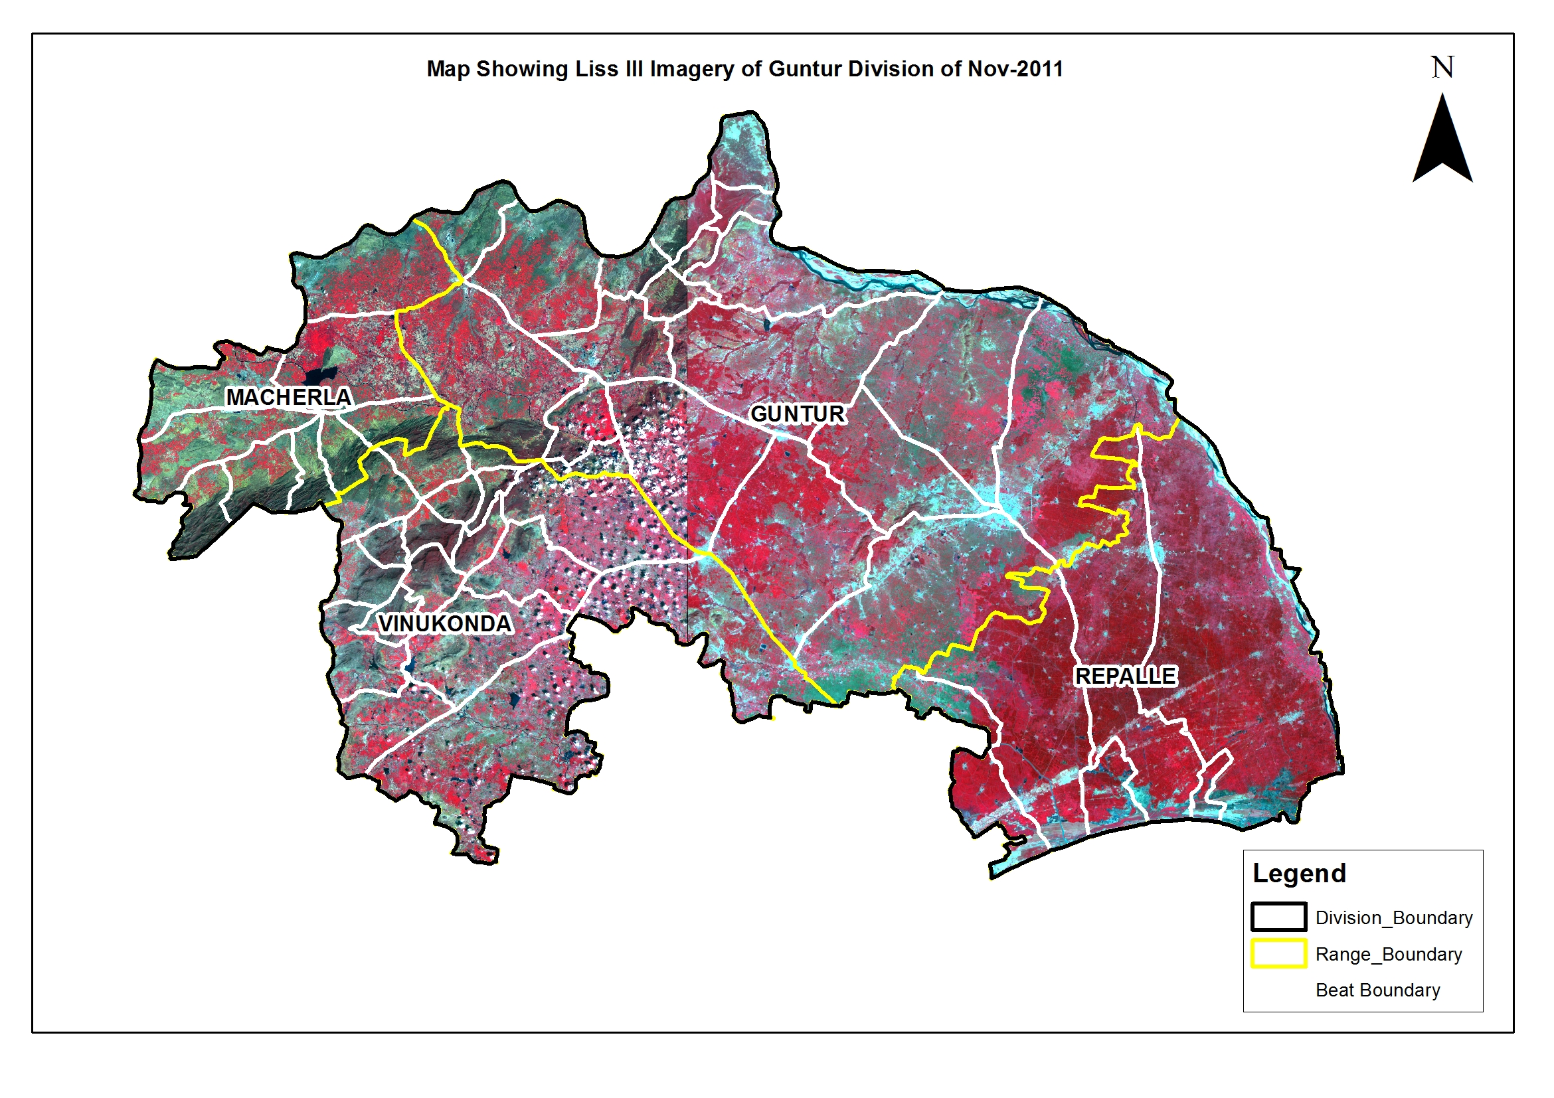

There are 57 Beats in the Division. Negative changes in forest cover are noticed in 16 Beats. There are no changes in the remaining 41 Beats.
Details of the forest cover along with changes in the Beats, are shown in Table 4.6.3.

Table 4.6.2: Forest Cover change matrix
(Area in Km²)
2011 | 2012 |  |  |  |  |  | Total of 2011
2011 | VDF | MDF | OF | Scrub | NF | Water | Total of 2011
Very Dense Forest | 0.00 | 0.00 | 0.00 | 0.00 | 0.00 | 0.00 | 0.00
Moderately Dense Forest | 0.00 | 124.24 | 0.00 | 0.00 | 0.00 | 0.00 | 124.24
Open Forest | 0.00 | 0.00 | 278.71 | 0.00 | 0.11 | 0.00 | 278.82
Scrub | 0.00 | 0.00 | 0.00 | 942.96 | 1.85 | 0.00 | 944.81
Non-Forest | 0.00 | 0.00 | 0.00 | 0.00 | 106.54 | 0.00 | 106.54
Water | 0.00 | 0.00 | 0.00 | 0.00 | 0.00 | 22.50 | 22.50
Total of 2012 | 0.00 | 124.24 | 278.71 | 942.96 | 108.50 | 22.50 | 1476.91
Net Change | 0.00 | 0.00 | -0.11 | -1.85 | 1.96 | 0.00

Table 4.6.3: List of Beats showing Forest Cover with Changes.
(Area in Ha)

BEAT | MDF | OF | SF | NF | WB | Total | Encroa-  Chments | NetChange
GUNTUR RANGE
Ameenabad | 0.00 | 21.17 | 773.49 | 450.12 | 2.23 | 1247.01 | 0.00 | 0.00
Atchampet | 494.04 | 947.84 | 1387.61 | 24.41 | 0.00 | 2853.90 | 0.00 | -4.24
Bodanam | 198.94 | 384.99 | 1084.65 | 24.95 | 0.00 | 1693.53 | 0.00 | 0.00
Chinthapalli | 617.43 | 1260.79 | 827.35 | 244.43 | 0.00 | 2949.99 | 0.00 | 0.00
Dodleru | 186.01 | 391.57 | 31.51 | 41.61 | 0.00 | 650.70 | 0.00 | -10.20
Enamdala | 0.00 | 891.84 | 1552.16 | 640.99 | 0.52 | 3085.51 | 0.00 | -20.96
Endroy | 0.00 | 1.45 | 501.46 | 297.55 | 0.00 | 800.47 | 0.00 | 0.00
Gundlapalli | 505.51 | 1048.91 | 1376.30 | 61.21 | 0.00 | 2991.92 | 2.20 | -7.51
Guthikonda | 822.24 | 1702.57 | 1381.00 | 40.09 | 0.00 | 3945.90 | 0.00 | -10.43
Konanki | 587.92 | 1322.13 | 859.26 | 131.68 | 0.00 | 2900.99 | 0.00 | 0.00
Kondaveedu | 2.72 | 453.75 | 623.82 | 138.73 | 0.00 | 1219.01 | 0.00 | 0.00
Madinapadu | 10.05 | 30.26 | 4191.48 | 431.74 | 0.00 | 4663.53 | 0.00 | 0.00
Mangalagiri | 0.00 | 86.99 | 487.14 | 86.57 | 0.00 | 660.70 | 0.00 | 0.00
Nekarikal | 259.47 | 488.44 | 1740.82 | 149.13 | 0.00 | 2637.86 | 0.00 | -1.59
Papayapalem | 596.65 | 1318.15 | 976.66 | 31.31 | 0.00 | 2922.76 | 9.56 | -9.56
Pulichintha | 604.98 | 864.60 | 2200.22 | 47.80 | 0.00 | 3717.59 | 0.00 | 0.00
Tripurapuram | 740.60 | 1720.82 | 1317.40 | 181.33 | 0.00 | 3960.14 | 1.35 | -15.56
Tsallagariga | 199.88 | 424.93 | 4525.26 | 87.28 | 0.00 | 5237.36 | 0.00 | -38.77
Vemavaram | 3.83 | 13.04 | 3016.99 | 140.06 | 0.00 | 3173.93 | 0.00 | 0.00
Venkatayapalem | 297.02 | 730.44 | 1617.68 | 6.39 | 0.00 | 2651.53 | 0.00 | 0.00
Total | 6127.28 | 14104.67 | 30472.26 | 3257.36 | 2.75 | 53964.31 | 13.11 | -118.82
MACHERLA RANGE
Adigoppula | 258.86 | 659.00 | 2199.56 | 18.79 | 0.00 | 3136.21 | 0.00 | 0.00
Daida | 1.03 | 3.07 | 1458.91 | 184.41 | 0.00 | 1647.41 | 0.00 | 0.00
Kakirala | 18.07 | 24.54 | 2111.05 | 4.63 | 0.00 | 2158.30 | 0.00 | 0.00
Loyapalli | 218.48 | 301.41 | 4301.73 | 45.38 | 0.00 | 4867.00 | 0.00 | 0.00
Macherla | 0.51 | 6.60 | 5046.16 | 460.84 | 0.00 | 5514.11 | 0.00 | 0.00
Madugula | 5.02 | 12.86 | 515.45 | 117.39 | 0.00 | 650.73 | 0.00 | 0.00
Minchalapadu | 228.35 | 243.66 | 3304.99 | 43.61 | 0.00 | 3820.61 | 0.00 | 0.00
Mutukuru | 357.58 | 664.97 | 3638.43 | 29.43 | 0.00 | 4690.41 | 0.00 | 0.00
Veldurthi | 8.96 | 27.14 | 2749.13 | 364.92 | 0.00 | 3150.15 | 0.00 | 0.00
Total | 1096.85 | 1943.26 | 25325.41 | 1269.40 | 0.00 | 29634.92 | 0.00 | 0.00
REPALLE RANGE
Adavuladeevi | 0.00 | 0.00 | 339.58 | 383.80 | 225.53 | 948.91 | 0.00 | 0.00
Dindi | 0.00 | 18.68 | 200.44 | 252.50 | 19.74 | 491.36 | 0.00 | 0.00
Muthayapalem A | 0.00 | 56.16 | 307.54 | 460.63 | 17.13 | 841.46 | 0.00 | 0.00
Muthayapalem B | 0.00 | 14.06 | 997.90 | 977.74 | 155.01 | 2144.71 | 0.00 | 0.00
Nizampatnam | 5.93 | 262.90 | 344.63 | 221.35 | 40.71 | 875.53 | 0.00 | 0.00
Puluguvaripalem | 0.00 | 340.92 | 564.09 | 498.48 | 40.96 | 1444.44 | 0.00 | 0.00
Total | 5.93 | 692.71 | 2754.18 | 2794.51 | 499.09 | 6746.41 | 0.00 | 0.00
VINUKONDA RANGE
Bollapalli | 686.17 | 1191.11 | 2051.71 | 18.53 | 0.00 | 3947.52 | 0.00 | 0.00
Chejerla | 763.56 | 1135.63 | 757.50 | 30.98 | 0.00 | 2687.68 | 0.00 | -11.05
Domalagudem | 21.97 | 62.67 | 2843.29 | 15.73 | 0.00 | 2943.66 | 0.00 | 0.00
Epuru East | 59.97 | 64.48 | 1649.13 | 55.44 | 0.00 | 1829.02 | 0.00 | -4.68
Epuru West | 587.75 | 953.44 | 1176.91 | 59.24 | 0.00 | 2777.33 | 0.00 | 0.00
Garikapadu | 256.52 | 646.24 | 1200.29 | 9.95 | 0.00 | 2113.00 | 0.00 | 0.00
Jayanthipuram | 479.63 | 893.60 | 722.67 | 30.81 | 0.00 | 2126.70 | 0.00 | -10.22
Kandrika | 268.93 | 416.45 | 3436.93 | 29.71 | 0.00 | 4152.02 | 0.00 | -12.29
Kanumulachervu | 132.23 | 328.66 | 4925.22 | 211.57 | 46.52 | 5644.19 | 0.00 | 0.00
Karempudi | 308.81 | 704.00 | 1903.98 | 4.59 | 0.00 | 2921.37 | 0.00 | 0.00
Mellavagu | 166.39 | 472.34 | 1474.67 | 3.69 | 0.00 | 2117.08 | 0.00 | 0.00
Naidupalem | 185.11 | 449.57 | 2604.74 | 46.83 | 15.08 | 3301.32 | 0.00 | -15.08
Ravulapuram | 402.96 | 962.83 | 1490.97 | 29.10 | 0.00 | 2885.86 | 0.00 | 0.00
Ravvaram | 20.49 | 62.69 | 1270.25 | 266.67 | 4.75 | 1624.85 | 0.00 | 0.00
Remidicherla | 796.29 | 1759.45 | 846.44 | 37.15 | 0.00 | 3439.33 | 0.00 | 0.00
Tangedumalli | 34.33 | 91.78 | 468.52 | 13.55 | 0.00 | 608.18 | 0.00 | 0.00
Tangirala | 17.28 | 22.97 | 1288.55 | 52.17 | 0.00 | 1380.96 | 0.00 | -13.60
Vaddemgunta | 5.64 | 8.54 | 2644.91 | 55.53 | 0.00 | 2714.61 | 0.00 | -10.21
Total | 5194.01 | 10226.43 | 32756.65 | 971.24 | 66.35 | 49214.68 | 0.00 | -77.13
WL-KRISHNA RANGE
Kothapalem(Wl) | 0.00 | 268.12 | 569.68 | 281.99 | 14.54 | 1134.33 | 0.00 | 0.00
Lanka Vanidibba(Wl) | 0.00 | 279.24 | 878.88 | 911.51 | 1396.46 | 3466.09 | 0.00 | 0.00
Mollagunta(Wl) | 0.00 | 357.17 | 1553.93 | 1334.22 | 286.31 | 3531.64 | 0.00 | 0.00
Total | 0.00 | 904.53 | 3002.49 | 2527.72 | 1697.31 | 8132.06 | 0.00 | 0.00
Grand Total | 12424.06 | 27871.61 | 94310.99 | 10820.23 | 2265.48 | 147692.37 | 13.11 | -195.95

2011 2012
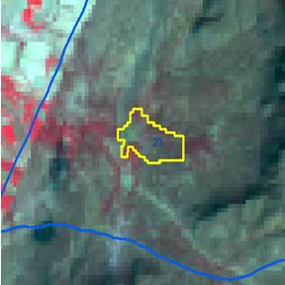
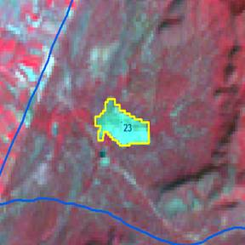

Longitude | 79.57691 ° E
Latitude | 16.17889 ° N
Area in Ha | 12.29
Change | Negative
Comp No. | 32
Beat | Kandrika
Range | Vinukonda
Division | Guntur

