**4.12 ELURU DIVISION**

**4.12.1 Introduction:**

Eluru Forest Division lies in the north-eastern part of Andhra Pradesh between latitudes 160 30’ 25.56’’ and 170 37’ 18.32’’N and longitudes 800 50’ 49’’and 810 50’ 59’’. Geographical area of the Division (and the District) is 8477.15 km2. The Division has two physiographic zones, the plains and the Hills. The climate of Eluru Division is characterized by high humidity nearly all the year round with oppressive summer and good seasonal rainfall. The major rivers falling in the Division are Godavari, Gauthami and Vasita.

Land use pattern of the Division is given in Table 4.12.1

**Table 4.12.1: Land use Pattern**

|  |  |  |
| --- | --- | --- |
| **Landuse** | **Area in sq.km.** | **Percentage** |
| Forest Including Scrub | 1187.72 | 14.01 |
| Agriculture | 5826.59 | 68.73 |
| Land With Scrub | 292.12 | 3.45 |
| Fallow Lands | 60.49 | 0.71 |
| Grass Lands | 2.65 | 0.03 |
| Settlements | 143.82 | 1.70 |
| Vegetation Outside Forest | 815.47 | 9.62 |
| Waterbodies | 145.29 | 1.72 |
| **Total** | **8477.15** |  |



Deccan traps, Alluvial deposits, Lower or upper Gondwana sediments, Khondalites and Charcolites occupy the district. Loamy soils, Lateritic and black cotton soils are found in the District. Temperature ranges from 170C to 450C and the annual rainfall is about 1076mm. South West monsoon gives more rain than North East monsoon.

The population of the Division (District) is 3.93 million (2011 census), per capita forest 0.02 Ha and the population density is 508 per Km2.

**4.12.2 Recorded Forest Area:**

The notified forest area of the Division is 1247.61 Km2 which is 14.71% of the geographical area.

As per the Champion and Seth’s classification, the forest types found in the Division are Tropical Moist Mixed Deciduous Forests,Tropical Dry Deciduous Scrub Forests and Tropical Dry Evergreen Scrub Forests.



**4.12.3 Protected Area:**

Two Protected Areas, viz., Kolleru and Papikonda Wild Life Sanctuaries fall partly in this Division. An area of 232.18 Km2 is included in the Kolleru WLS which is the largest fresh water lake in the Country and also a Ramsar site. Papikonda Wild Life Sanctuary occupies 403.47 Km2 of the forest area of the Division.

**4.12.4 Community Forest Management:**

There are 213 VSSs in the Division. An area of 414.54 Km2 of forests, which constitutes 53% of forest area, is under the management of VSSs.

**Fig 4. 12.1**

**4.12.5 Forest Cover:**

The forest cover in the Division based on the interpretation of IRS R2 LISS III 2013 data (Dec\Feb 2014) is **1053.47 Km2** which is 12.42% of the geographical area.Interms of the forestcanopy cover density classes, the Division has **91.91** Km2of very Dense Forests **877.60** Km2 of Moderately Dense Forests and **83.97** Km2 of Open Forests. The area of the Scrub is **134.24** Km2, Non-Forest **59.01** Km2 and Water Bodies **0.88** Km2. The distribution of the forest cover of the Division is shown in Fig 4.12.1.

**4.12.6 Change in Forest Cover:**

The satellite images of 2011 and 2012 are shown in Figs 4.12.2 & 4.12.3 respectively and the changes between this period are shown on the image of 2012.

Comparison of the current forest cover with that of previous assessment year shows a **negative change of 902.54 Ha** and **positive change of 717.53 Ha**. The forest cover change matrix given in Table 4.12.2 reveals that there is a decrease of **185.01** Ha of open forest and increase of **63.67** Ha of scrub forest and increase of **121.34** Ha of Non forest.

The total positive change (including scrub) of **1025.75** Ha is on account of growth **792.38** Ha of raised plantations and **233.37** ha of improvement plan.The total negative change (including scrub) is **1134.78** Ha. Out of this, **779.55** Ha is on account of clearance of jungle growth for raising of plantations, **263.95** Ha is on account of harvesting of plantations and **91.28** Ha is on account of encroachments. As clearance of jungle growth for raising of plantations and harvesting of plantations are forest management interventions, the same are not considered as loss of forest cover. Thus the negative change due to encroachments alone is taken as loss of forest cover. Therefore, the **net loss of forest cover is 91.28 Ha** in the Division.

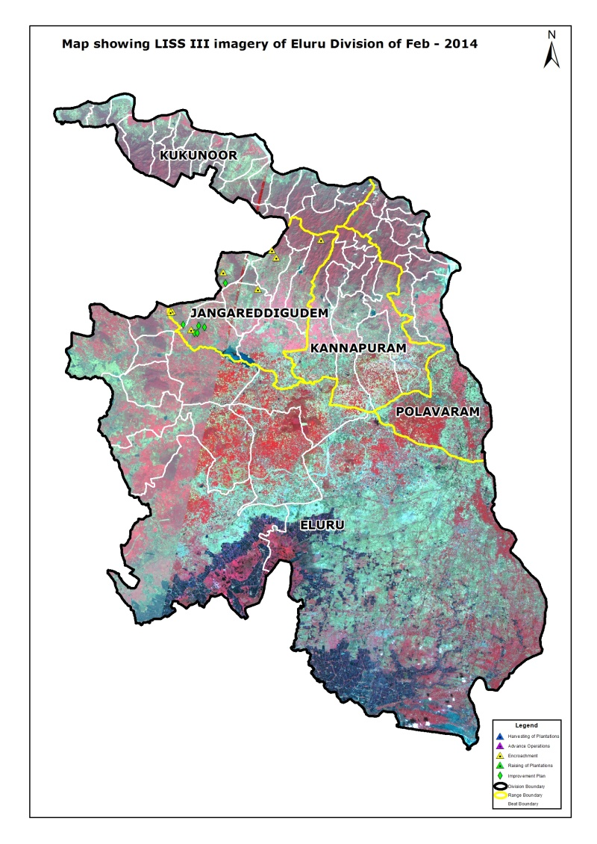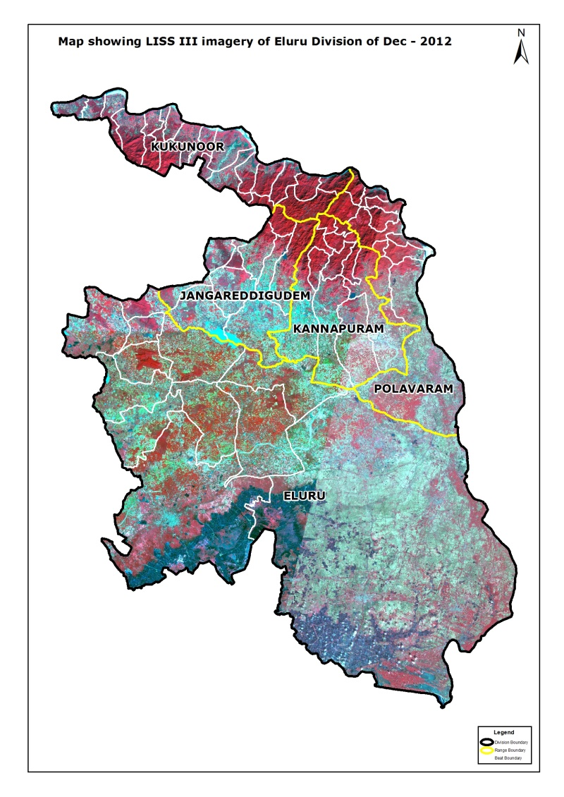

**Fig 4.12.3**

**Fig 4.12.2**

There are 66 Beats in the Division. Negative changes in forest cover are seen in 9 Beats and Positive changes in forest cover are seen in 9 Beats. There is no change in the remaining 48 Beats. Details of forest cover changes in these Beats along with other remaining beats are shown in Table 4.12.3.

**Fig 4. 31.2**

**Table 4.12.2: Forest Cover change matrix**

(Area in Km2)

|  |  |  |  |  |  |  |  |
| --- | --- | --- | --- | --- | --- | --- | --- |
| **2012** | **2013** | | | | | | **Total of 2012** |
|  | **VDF** | **MDF** | **OF** | **Scrub** | **NF** | **Water** |
| Very Dense Forest | 91.91 | 0.00 | 0.00 | 0.00 | 0.00 | 0.00 | 91.91 |
| Moderately Dense Forest | 0.00 | 877.60 | 0.00 | 0.00 | 0.00 | 0.00 | 877.60 |
| Open Forest | 0.00 | 0.00 | 76.79 | 5.21 | 3.81 | 0.00 | 85.81 |
| Scrub | 0.00 | 0.00 | 5.34 | 125.95 | 2.32 | 0.00 | 133.61 |
| Non-Forest | 0.00 | 0.00 | 1.84 | 3.08 | 52.88 | 0.00 | 57.80 |
| Water | 0.00 | 0.00 | 0.00 | 0.00 | 0.00 | 0.88 | 0.88 |
| **Total of 2013** | **91.91** | **877.60** | **83.97** | **134.24** | **59.01** | **0.88** | **1247.61** |
| Net Change | 0.00 | 0.00 | -1.84 | 0.63 | 1.21 | 0.00 |  |

**Table 4.1.3: List of Beats showing Forest Cover with changes (Area in Ha)**

|  |  |  |  |  |  |  |  |  |  |
| --- | --- | --- | --- | --- | --- | --- | --- | --- | --- |
| **Beat** | **VDF** | **MDF** | **OF** | **SF** | **NF** | **WB** | **TOTAL** | **Netchange** | **Encroachment** |
| **Eluru Range** | | | | | | | |  |  |
| A R Palem | 0.00 | 674.92 | 303.61 | 576.33 | 135.82 | 0.00 | 1,690.68 | 15.58 | 0.00 |
| Barrikonda | 0.00 | 586.27 | 527.20 | 315.32 | 85.83 | 1.51 | 1,516.13 | -4.64 | 0.00 |
| Bhogole | 0.00 | 216.00 | 313.43 | 695.57 | 393.53 | 16.04 | 1,634.57 | 119.75 | 0.00 |
| Chintalapudi | 0.00 | 1,948.62 | 164.87 | 102.21 | 85.24 | 0.00 | 2,300.94 | 26.87 | 0.00 |
| Dubacherla | 0.00 | 821.31 | 226.83 | 239.32 | -18.44 | 0.00 | 1,269.02 | 54.89 | 0.00 |
| M.V.Gudem | 0.00 | 1,570.53 | 323.13 | 495.61 | 121.15 | 0.00 | 2,510.42 | -11.93 | 0.00 |
| Nallajerla | 0.00 | 598.28 | 220.23 | 608.26 | 141.08 | 0.00 | 1,567.85 | 9.17 | 0.00 |
| R.S.Varam | 0.00 | 515.04 | 394.57 | 404.36 | 73.35 | 0.00 | 1,387.32 | -2.64 | 0.00 |
| Thadikelapudi | 0.00 | 336.66 | 97.50 | 886.32 | 209.77 | 0.00 | 1,530.25 | -18.59 | 0.00 |
| V.R.Gudem | 0.00 | 71.72 | 76.66 | 561.40 | 456.16 | 48.41 | 1,214.35 | 19.13 | 0.00 |
| Velagalapalli | 0.00 | 43.54 | 159.49 | 1,235.25 | 576.19 | 0.00 | 2,014.47 | 14.61 | 0.00 |
| Yerraguntapalli | 0.00 | 611.95 | 271.19 | 260.67 | 98.80 | 0.00 | 1,242.61 | 0.00 | 0.00 |
| **Total** | **0.00** | **7,994.84** | **3,078.71** | **6,380.62** | **2,358.48** | **65.96** | **19,878.61** | **222.20** | **0.00** |
| **Jangareddigudem Range** | | | | | | | |  |  |
| Aliveru | 115.03 | 3,099.02 | 0.98 | 12.80 | 3.77 | 0.00 | 3,231.60 | 0.00 | 0.00 |
| Ankannagudem | 0.00 | 824.80 | 63.51 | 211.37 | 131.60 | 0.00 | 1,231.28 | 0.00 | 0.00 |
| Antarvedigudem | 14.93 | 1,283.16 | -2.01 | 72.24 | 34.94 | 0.00 | 1,403.26 | -3.74 | 3.74 |
| Darbhagudem | 0.00 | 228.33 | 616.16 | 340.03 | 145.82 | 0.00 | 1,330.34 | 138.40 | 36.60 |
| Doramamidi | 5.74 | 777.54 | 6.31 | 90.20 | 5.99 | 0.00 | 885.78 | 0.00 | 0.00 |
| Gullapudi | 492.48 | 3,610.62 | 3.02 | 70.57 | 26.45 | 3.27 | 4,206.41 | -5.89 | 6.98 |
| Jeelugumilli | 0.00 | 604.37 | 398.62 | 285.10 | 222.60 | 0.00 | 1,510.69 | -165.42 | 12.19 |
| Kamaiahpalem | 0.00 | 753.36 | 330.48 | 646.68 | 355.00 | 0.00 | 2,085.52 | -134.67 | 28.92 |
| Marlagudem | 0.00 | 134.17 | 115.89 | 408.98 | 164.73 | 0.00 | 823.77 | 8.26 | 0.00 |
| Mulagalampalli | 0.00 | 344.90 | -69.88 | 1,426.88 | 829.14 | 0.00 | 2,531.04 | -168.17 | 2.85 |
| **Total** | **628.18** | **11,660.27** | **1,463.08** | **3,564.85** | **1,920.04** | **3.27** | **19,239.69** | **-331.23** | **91.28** |
| **Kannapuram Range** | | | | | | | |  |  |
| Chinthapalli | 122.37 | 1,489.90 | 1.84 | 1.46 | 0.00 | 0.00 | 1,615.57 | 0.00 | 0.00 |
| Dandipudi | 603.25 | 2,751.62 | 10.34 | 64.91 | 97.65 | 0.00 | 3,527.77 | 0.00 | 0.00 |
| Kallumamidi | 428.01 | 728.71 | 1.04 | 1.28 | 0.00 | 0.00 | 1,159.04 | 0.00 | 0.00 |
| Karakapadu | 0.00 | 501.79 | 1.69 | 37.30 | 23.25 | 13.75 | 577.78 | 0.00 | 0.00 |
| Kopalli | 94.24 | 2,103.16 | 0.91 | 1.89 | 1.29 | 0.00 | 2,201.49 | 0.00 | 0.00 |
| Kotrupalli | 46.73 | 963.50 | 2.10 | 2.83 | 0.00 | 0.00 | 1,015.16 | 0.00 | 0.00 |
| Kovvada | 8.34 | 1,135.41 | 20.73 | 285.50 | 72.48 | 0.00 | 1,522.46 | 0.00 | 0.00 |
| Kunkala | 51.07 | 2,277.95 | 6.95 | 59.97 | 3.60 | 0.04 | 2,399.58 | 0.00 | 0.00 |
| L N D Pet | 185.52 | 1,805.17 | 38.18 | 66.59 | 2.90 | 0.00 | 2,098.36 | 0.00 | 0.00 |
| P R Gudem | 315.33 | 2,062.06 | 16.73 | 43.01 | 15.58 | 0.00 | 2,452.71 | 0.00 | 0.00 |
| **Total** | **1,854.86** | **15,819.27** | **100.51** | **564.74** | **216.75** | **13.79** | **18,569.92** | 0.00 | 0.00 |
| **Kukunoor Range** |  |  |  |  |  |  |  |  |  |
| Amararam | 231.80 | 3,928.61 | 334.59 | 277.28 | 102.52 | 0.00 | 4,874.80 | 0.00 | 0.00 |
| Cheeravalli | 0.00 | 721.46 | 107.97 | 87.95 | 34.53 | 0.00 | 951.91 | 0.00 | 0.00 |
| Chigurumamidi | 175.58 | 2,658.54 | 216.62 | 61.10 | 12.33 | 0.00 | 3,124.17 | 0.00 | 0.00 |
| Damaracherla | 395.75 | 3,034.06 | 243.08 | 220.98 | 84.50 | 0.00 | 3,978.37 | 0.00 | 0.00 |
| Gollagudem | 51.62 | 1,664.51 | 79.32 | 66.58 | 23.77 | 0.00 | 1,885.80 | 0.00 | 0.00 |
| Goparaju Gudem | 0.00 | 464.43 | 170.04 | 172.75 | 127.17 | 0.00 | 934.39 | 0.00 | 0.00 |
| Gummadapally | 0.80 | 1,269.11 | 454.82 | 548.92 | 322.13 | 0.00 | 2,595.78 | 0.00 | 0.00 |
| Gundambore | 0.00 | 330.55 | 143.49 | 83.08 | 19.17 | 0.00 | 576.29 | 0.00 | 0.00 |
| Kakeshnuru | 543.77 | 2,034.06 | 187.03 | 42.55 | 30.08 | 0.00 | 2,837.49 | 0.00 | 0.00 |
| Kavadigundla East | 230.77 | 1,103.31 | 12.12 | 2.31 | 0.00 | 0.00 | 1,348.51 | 0.00 | 0.00 |
| Kavadigundla North | 15.81 | 603.38 | 25.75 | 7.95 | 0.00 | 0.00 | 652.89 | 0.00 | 0.00 |
| Koida | 375.77 | 2,280.37 | 34.07 | 26.76 | 8.54 | 0.00 | 2,725.51 | 0.00 | 0.00 |
| Kothur | 2.24 | 1,354.68 | 214.84 | 215.97 | 194.01 | 2.37 | 1,984.11 | 0.00 | 0.00 |
| Kukunoor | 0.00 | 741.10 | 151.41 | 98.28 | 26.34 | 0.00 | 1,017.13 | 0.00 | 0.00 |
| Lankalapally | 0.00 | 568.80 | 234.79 | 177.79 | 48.39 | 0.00 | 1,029.77 | 0.00 | 0.00 |
| Nandipadu | 299.53 | 2,604.26 | 150.38 | 86.80 | 10.26 | 0.00 | 3,151.23 | 0.00 | 0.00 |
| Parantapally | 2,296.35 | 4,111.69 | 152.64 | 14.65 | 0.00 | 0.00 | 6,575.33 | 0.00 | 0.00 |
| Raigudem | 0.00 | 731.84 | 237.13 | 178.72 | 108.50 | 0.00 | 1,256.19 | 0.00 | 0.00 |
| Rudramkota | 0.00 | 407.47 | 166.92 | 102.51 | 58.82 | 0.00 | 735.72 | 0.00 | 0.00 |
| Sreedhara | 0.00 | 448.82 | 159.38 | 95.36 | 35.77 | 0.00 | 739.33 | 0.00 | 0.00 |
| Tekupally | 423.87 | 2,560.69 | 72.34 | 19.93 | 13.85 | 0.00 | 3,090.68 | 0.00 | 0.00 |
| Vinjaram | 0.00 | 813.86 | 166.65 | 155.58 | 101.18 | 0.00 | 1,237.27 | 0.00 | 0.00 |
| **Total** | **5,043.66** | **34,435.60** | **3,715.38** | **2,743.80** | **1,361.86** | **2.37** | **47,302.67** | 0.00 | 0.00 |
| **Polavaram Range** | | | | | | | |  |  |
| Chilakaluru | 796.14 | 2,185.38 | 0.49 | 36.82 | 8.10 | 0.00 | 3,026.93 | 0.00 | 0.00 |
| Kondrukota | 293.97 | 3,278.75 | 2.41 | 7.80 | 0.00 | 0.00 | 3,582.93 | 0.00 | 0.00 |
| Kothuru | 6.26 | 661.44 | 2.59 | 2.75 | 0.69 | 0.00 | 673.73 | 0.00 | 0.00 |
| Nettappakota | 172.13 | 1,817.11 | 0.00 | 3.97 | 0.00 | 0.00 | 1,993.21 | 0.00 | 0.00 |
| Polavaram | 12.41 | 1,125.34 | 1.99 | 16.11 | 13.90 | 0.00 | 1,169.75 | 0.00 | 0.00 |
| Sirivaka | 115.84 | 1,728.69 | 21.52 | 64.75 | 12.43 | 2.84 | 1,946.07 | 0.00 | 0.00 |
| Sivagiri | 0.87 | 1,097.84 | 4.55 | 12.54 | 7.01 | 0.00 | 1,122.81 | 0.00 | 0.00 |
| Tekuru | 0.00 | 1,444.32 | 1.57 | 5.20 | 0.00 | 0.00 | 1,451.09 | 0.00 | 0.00 |
| Tutigunta | 180.81 | 2,548.53 | 0.52 | 6.93 | 1.95 | 0.00 | 2,738.74 | 0.00 | 0.00 |
| Udathapalli | 85.02 | 674.73 | 0.00 | 0.20 | 0.00 | 0.00 | 759.95 | 0.00 | 0.00 |
| Vadapalli | 0.00 | 98.94 | 0.00 | 0.00 | 0.00 | 0.00 | 98.94 | 0.00 | 0.00 |
| Vinjaram | 0.69 | 1,189.16 | 2.74 | 13.49 | 0.00 | 0.00 | 1,206.08 | 0.00 | 0.00 |
| **Total** | **1,664.14** | **17,850.23** | **38.38** | **170.56** | **44.08** | **2.84** | **19,770.23** | 0.00 | 0.00 |
| **Grand Total** | **9,190.84** | **87,760.21** | **8,396.06** | **13,424.57** | **5,901.21** | **88.23** | **124,761.12** | **-109.03** | **91.28** |



**2012 2013**































|  |  |
| --- | --- |
| Longitude | 81.401785 **E** |
| Latitude | 16.844248 N |
| Area in Ha | 19.13 |
| Change | POSITIVE |
| Comp No. | 219 |
| Beat | V.R.GUDEM |
| Range | ELURU |
| Division | ELURU |