4.20 CHITTOOR EAST WL DIVISION

4.20.1 Introduction:
Chittoor East WL Forest Division lies in the south of Andhra Pradesh and eastern Part of Chittoor District between latitudes 13⁰ 1’ 7.32” and 13⁰ 55’28.56” N and longitudes 78⁰ 46’ 50.88”and 80⁰ 03’ 10.44” E. The Geographical Area of the Division is 6,769.18 Km² which is 44.58 % of the area of the District. The Eastern Ghats are predominant in the western region and they gradually bend towards the sacred Sheshachalam hills of Tirupati, passing through Chandragiri, erstwhile taluk and entering into Nellore district. There is a plateau of average height of 800 M above MSL. The rivers flowing in the Division are non-perennial in nature. Important rivers in the Division are Bheema- a tributary of river Swarnamukhi, Pincha , Tumbur kona, Kalangi, Arani and Ponnai.
Land use pattern of the Division is given in Table 4.20.1
The climate of this Division is healthy and pleasant. The temperatures range from 16⁰C to 46⁰C and the rain fall of the Division is received both from the South-West and North-East Monsoons. Annual rainfall is about 880 mm (average of past 12 years) and only 450 mm is received from the South-West Monsoon.
The major portion of the Division is covered by red loamy and sandy soils with portions of alluvial soil. The sandy loams constitute 55% of the soils in the Division; sandy clay loams 30% to 32%, clay soils 3% and the balance by Red clay soils and black sandy soils.
The population of the Division is 1.86 million (2001 Census), per capita forest area is 0.11 Ha. The Population density is 274 persons per Km^{2.}
4.20.2 Recorded Forest Area:
The notified forest area of the Division is 2452.08 Km² which is 36.22% of the geographical area. Reserved and Protected Forests constitute 1976.68 Km² (80.61%) and 475.4 Km² (19.39%) of the forest area respectively.
Table 4.20.1: Land use Pattern
Land use | Area in Sq. km. | Percentage
Forest including Scrub | 1809.48 | 26.73
Agriculture | 3371.05 | 49.80
Land with Scrub | 903.77 | 13.35
Fallow Lands | 299.68 | 4.43
Grasslands | 30.62 | 0.45
Settlements | 24.06 | 0.36
Vegetation outside forest | 121.06 | 1.79
Water Bodies | 209.45 | 3.09
Total | 6769.18

As per Champion and Seth’s classification, the Forests of Division fall under Tropical Dry Mixed Deciduous Forests, Tropical Cutch Thorn Forest groups & Tropical Dry Evergreen Forest types.

4.20.3 Protected Area:
There is no Protected Area in the Division.

4.20.4 Community Forest Management:
There are 225 Vana Samrakshana Samities (VSSs) in the Division. An area of 567.7 Km² forests, which constitutes 28.37 % of the notified forests, is under the management of the VSSs.
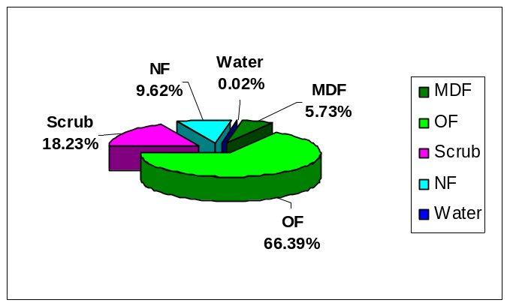
Fig 4.20.1
4.20.5 Forest Cover:
The forest cover in the Division based on the interpretation of IRS R2 LISS III 2012 data (Feb/Mar 2012) is 1343.02 Km² which is 19.84% of the Geographical area. In terms of the forest canopy density classes the Division has 0.00 Km² of Very Dense Forest, 306.84 Km² of Moderately Dense Forest and 1036.18 Km² of Open Forest. The area of the Scrub is 451.32 Km², Non-Forest 92.23 and Water Bodies 0.25 Km². The Distribution of the forest cover of the Division is shown in fig 4.20.1.
4.20.6 Change in Forest Cover:
The satellite images of 2011 and 2012 are shown in Figs 4.20.2 & 4.20.3 respectively and the changes between this period are shown on the image of 2012.

Comparison of the current forest cover with that of previous assessment year shows a negative change of 21.16 Ha .The forest cover change matrix given in Table 4.20.2 reveals that there has been a decrease of 21.16 Ha open forest.

The total positive change (including scrub) is 315.62 Ha. Out of this, 305.58 Ha improvement is on account of growth in raised plantations and 10.04 Ha is on account of improvement of forest due to protection and management interventions. The total negative change (including scrub) is 65.40Ha. Of this, 22.59 Ha is on account of clearance of jungle growth for raising of plantations and the remaining 42.81 Ha is on account of encroachment . As clearance of jungle growth for raising of plantations is forest management interventions, the same are not considered as loss of forest cover. Thus the negative change due to encroachments only are taken as loss of forest cover. Therefore, the net loss of forest cover in the Division is 176.37 Ha.

Fig 4.20.2
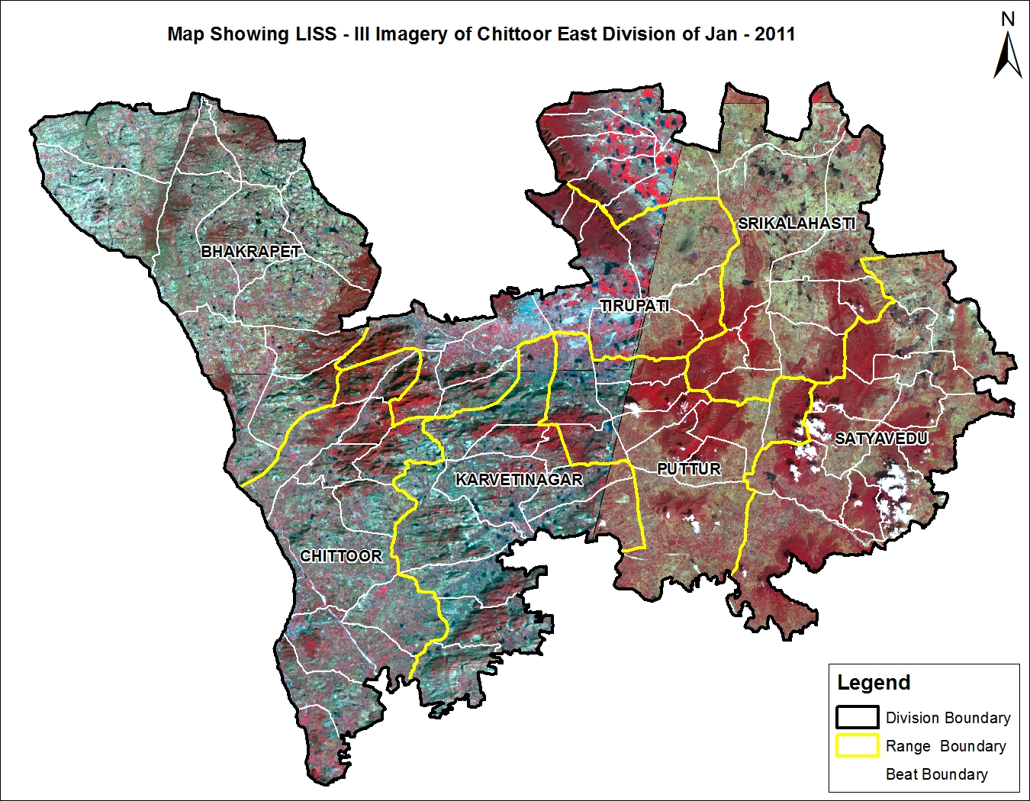

Fig 4.20.3
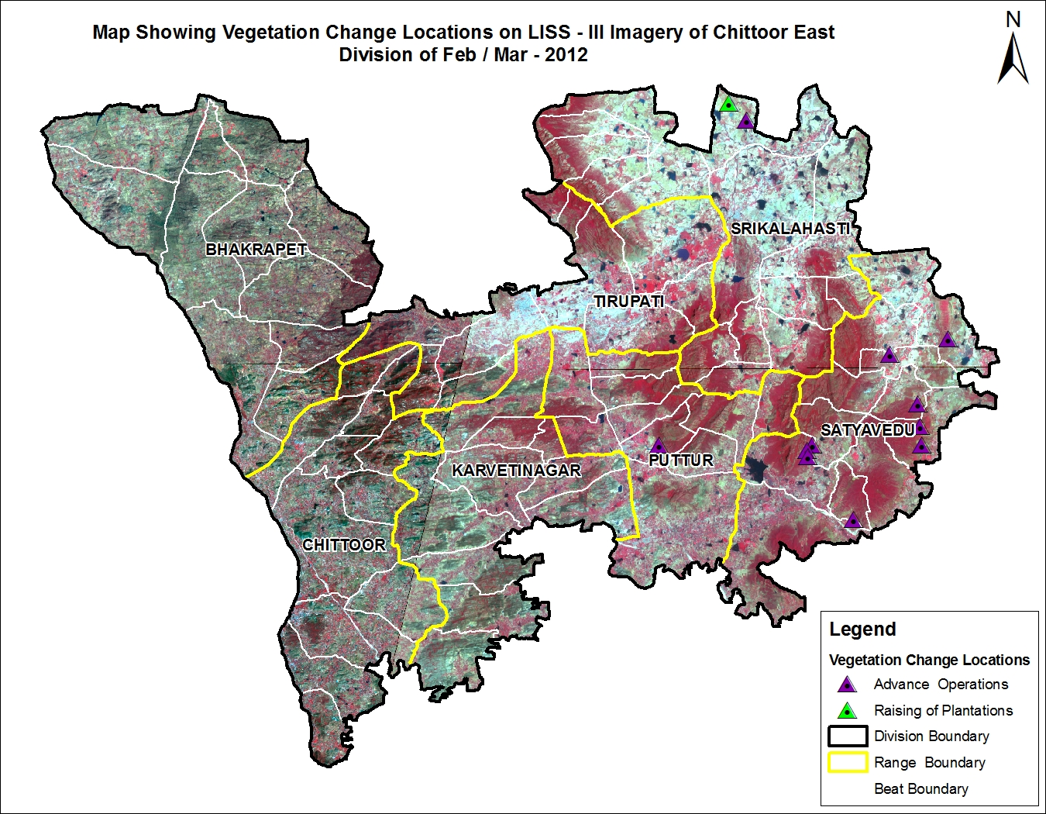

There are 78 Beats in the Division. Negative changes in forest cover are noticed in 5 Beats and Positive changes are in 9 Beats. There is no change in the remaining 64 Beats.

Details of forest cover changes in the 14 Beat mentioned above, is shown in Table 4.20.3
(Area in Km²)
Table 4.20.2: Forest Cover change matrix
2011 | 2012 |  |  |  |  |  | Total of 2011
2011 | VDF | MDF | OF | Scrub | NF | Water | Total of 2011
Very Dense Forest | 0.00 | 0.00 | 0.00 | 0.00 | 0.00 | 0.00 | 0.00
Moderately Dense Forest | 0.00 | 306.84 | 0.00 | 0.00 | 0.00 | 0.00 | 306.84
Open Forest | 0.00 | 0.00 | 1034.20 | 0.21 | 0.00 | 0.00 | 1034.41
Scrub | 0.00 | 0.00 | 1.98 | 449.93 | 0.44 | 0.00 | 452.35
Non-Forest | 0.00 | 0.00 | 0.00 | 1.18 | 91.79 | 0.00 | 92.97
Water | 0.00 | 0.00 | 0.00 | 0.00 | 0.00 | 0.25 | 0.25
Total of 2012 | 0.00 | 306.84 | 1036.18 | 451.32 | 92.23 | 0.25 | 1886.82
Net Change | 0.00 | 0.00 | 1.77 | -1.03 | -0.74 | 0.00
(Area in Ha)

Table 4.20.3: List of Beats with negative change in Forest Cover

BEAT |  | VDF | MDF |  | OF |  | SCRUB |  | NF |  | WB |  | Total |  | ENCR |  | NET CHANGE
BHAKRAPET RANGE
Ganugapenta |  | 0 | 516.568 |  | 1672.175 |  | 491.57 |  | 157.756 |  | 6.995 |  | 2845.064 |  | 0.00 |  | 0.00
Mangalampet |  | 0 | 410.339 |  | 2552.647 |  | 645.716 |  | 286.016 |  | 0 |  | 3894.718 |  | 0.00 |  | 0.00
Marella |  | 0 | 8.495 |  | 73.818 |  | 1043.453 |  | 639.596 |  | 0 |  | 1765.362 |  | 0.00 |  | 0.00
Mellacheruvu |  | 0 | 8.799 |  | 77.194 |  | 1213.831 |  | 289.578 |  | 0 |  | 1589.402 |  | 0.00 |  | 0.00
Peddamallela |  | 0 | 1.937 |  | 390.287 |  | 920.035 |  | 149.847 |  | 0 |  | 1462.106 |  | 0.00 |  | 10.04
Pudipatlabailu |  | 0 | 14.482 |  | 849.227 |  | 958.948 |  | 45.341 |  | 0 |  | 1867.998 |  | 0.00 |  | 0.00
Talapula |  | 0 | 0 |  | 139.037 |  | 1929.012 |  | 796.356 |  | 0 |  | 2864.405 |  | 5.19 |  | -5.19
Ustikayalapenta |  | 0 | 21.271 |  | 314.397 |  | 2484.814 |  | 753.828 |  | 0 |  | 3574.31 |  | 0.00 |  | 0.00
Vagalla |  | 0 | 6.843 |  | 277.038 |  | 1767.84 |  | 1078.889 |  | 0 |  | 3130.61 |  | 0.00 |  | 0.00
Total |  | 0 | 988.734 |  | 6345.82 |  | 11455.22 |  | 4197.207 |  | 6.995 |  | 22993.98 |  | 5.19 |  | 4.85
CHITTOOR RANGE
Bommasamudram |  | 0 | 111.13 |  | 1030.12 |  | 264.737 |  | 17.277 |  | 0 |  | 1423.264 |  | 0.00 |  | 6.77
Chasses Hills |  | 0 | 130.692 |  | 738.161 |  | 156.188 |  | 34.326 |  | 0 |  | 1059.367 |  | 9.29 |  | -9.29
Chittoor |  | 0 | 37.358 |  | 755.899 |  | 372.333 |  | 43.803 |  | 2.178 |  | 1211.571 |  | 0.00 |  | 0.00
Kasipentla |  | 0 | 560.377 |  | 1317.614 |  | 97.534 |  | 61.179 |  | 0 |  | 2036.704 |  | 0.00 |  | 0.00
Mungilipattu |  | 0 | 1076.883 |  | 1726.861 |  | 300.212 |  | 70.932 |  | 0 |  | 3174.888 |  | 0.00 |  | 0.00
Nendragunta |  | 0 | 326.241 |  | 1947.198 |  | 203.02 |  | 16.979 |  | 0 |  | 2493.438 |  | 0.00 |  | 0.00
Oddepalli |  | 0 | 347.758 |  | 1354.126 |  | 272.549 |  | 43.461 |  | 2.281 |  | 2020.175 |  | 0.00 |  | 0.00
Pachigunta |  | 0 | 8.08 |  | 278.939 |  | 347.331 |  | 64.596 |  | 0 |  | 698.946 |  | 0.00 |  | 0.00
Panapakam |  | 0 | 464.063 |  | 1947.929 |  | 174.497 |  | 24.154 |  | 0.76 |  | 2611.403 |  | 0.00 |  | 0.00
Pathagunta |  | 0 | 523.838 |  | 1403.724 |  | 149.132 |  | 32.943 |  | 0 |  | 2109.637 |  | 0.00 |  | 0.00
Penumur |  | 0 | 121.65 |  | 1047.625 |  | 412.8 |  | 56.185 |  | 0 |  | 1638.26 |  | 0.00 |  | 0.00
Puthalapattu |  | 0 | 20.522 |  | 871.309 |  | 695.582 |  | 133.261 |  | 0 |  | 1720.674 |  | 13.86 |  | -13.86
Total |  | 0 | 3728.592 |  | 14419.51 |  | 3445.915 |  | 599.096 |  | 5.219 |  | 22198.33 |  | 23.15 |  | -16.38
KARVETINAGAR RANGE
Allamadugu |  | 0 | 41.295 |  | 1521.553 |  | 1119.229 |  | 276.054 |  | 0 |  | 2958.131 |  | 0.00 |  | 0.00
Amudala |  | 0 | 142.084 |  | 782.199 |  | 822.059 |  | 488.15 |  | 0 |  | 2234.492 |  | 0.00 |  | 0.00
G.V.Puram |  | 0 | 664.485 |  | 1047.214 |  | 622.862 |  | 212.021 |  | 0 |  | 2546.582 |  | 0.00 |  | 0.00
Karvetinagar |  | 0 | 939.233 |  | 320.286 |  | 26.085 |  | 16.685 |  | 0 |  | 1302.289 |  | 0.00 |  | 0.00
Nissankadurgam |  | 0 | 222.357 |  | 762.66 |  | 445.842 |  | 292.126 |  | 0 |  | 1722.985 |  | 0.00 |  | 0.00
Palasamudram |  | 0 | 205.276 |  | 2653.664 |  | 848.938 |  | 155.192 |  | 0 |  | 3863.07 |  | 0.00 |  | 0.00
R.K.M.Puram |  | 0 | 1355.637 |  | 457.376 |  | 56.793 |  | 26.871 |  | 0 |  | 1896.677 |  | 0.00 |  | 0.00
Rayalacheruvu |  | 0 | 668.902 |  | 785.367 |  | 306.875 |  | 96.061 |  | 0 |  | 1857.205 |  | 0.00 |  | 0.00
Srpuram |  | 0 | 151.342 |  | 1803.611 |  | 831.49 |  | 266.081 |  | 0 |  | 3052.524 |  | 0.00 |  | 0.00
Surendranagar |  | 0 | 510.046 |  | 682.511 |  | 120.618 |  | 15.15 |  | 0 |  | 1328.325 |  | 0.00 |  | 0.00
Total |  | 0 | 4900.657 |  | 10816.44 |  | 5200.791 |  | 1844.391 |  | 0 |  | 22762.28 |  | 0.00 |  | 0.00
PUTTUR RANGE
Battikandriga |  | 0 | 1195.714 |  | 323.766 |  | 12.984 |  | 8.185 |  | 0 |  | 1540.649 |  | 0.00 |  | 0.00
Diguvaputtur |  | 0 | 295.283 |  | 2184.683 |  | 1055.75 |  | 0 |  | 0 |  | 3535.716 |  | 0.00 |  | 0.00
Gullur Puttur |  | 0 | 1303.442 |  | 580.18 |  | 53.081 |  | 19.294 |  | 0 |  | 1955.997 |  | 0.00 |  | 0.00
Nagari |  | 0 | 45.25 |  | 886.252 |  | 2020.089 |  | 771.756 |  | 0 |  | 3723.347 |  | 0.00 |  | -11.21
Padiredu Gollapalle |  | 0 | 943.025 |  | 1216.521 |  | 202.382 |  | 46.878 |  | 3.434 |  | 2412.24 |  | 0.00 |  | 0.00
Palamangalam |  | 0 | 17.556 |  | 1131.596 |  | 986.226 |  | 4.775 |  | 0 |  | 2140.153 |  | 0.00 |  | 0.00
Puttur Moolapalem |  | 0 | 83.778 |  | 2011.047 |  | 755.92 |  | 5.669 |  | 0 |  | 2856.414 |  | 0.00 |  | 5.20
Taduku |  | 0 | 470.214 |  | 1481.275 |  | 503.954 |  | 4.992 |  | 0.919 |  | 2461.354 |  | 0.00 |  | 9.49
Vadamalpet |  | 0 | 1309.152 |  | 1531.837 |  | 355.116 |  | 76.405 |  | 1.912 |  | 3274.422 |  | 0.00 |  | 0.00
Vagathur |  | 0 | 513.886 |  | 2344.714 |  | 392.352 |  | 15.226 |  | 0 |  | 3266.178 |  | 0.00 |  | 0.00
Total |  | 0 | 6177.3 |  | 13691.87 |  | 6337.854 |  | 953.18 |  | 6.265 |  | 27166.47 |  | 0.00 |  | 3.48
SATYAVEDU RANGE
Ambakam |  | 0 | 764.659 |  | 4211.182 |  | 1084.39 |  | 2.632 |  | 0 |  | 6062.863 |  | 0.00 |  | 0.00
Bhupatheeswarapuram |  | 0 | 165.121 |  | 3576.057 |  | 1032.627 |  | 23.316 |  | 0 |  | 4797.121 |  | 0.00 |  | 0.00
Kadur |  | 0 | 28.738 |  | 862.069 |  | 1987.528 |  | 178.993 |  | 0 |  | 3057.328 |  | 7.79 |  | 11.92
Kambakam |  | 0 | 323.444 |  | 3320.077 |  | 1080.677 |  | 39.985 |  | 0 |  | 4764.183 |  | 0.00 |  | 0.00
Nagalapuram |  | 0 | 367.435 |  | 2913.472 |  | 615.411 |  | 5.599 |  | 0 |  | 3901.917 |  | 0.00 |  | 19.88
Nandanam |  | 0 | 161.242 |  | 2616.51 |  | 783.278 |  | 0 |  | 0 |  | 3561.03 |  | 0.00 |  | 0.00
Pandur |  | 0 | 58.129 |  | 1239.887 |  | 1402.916 |  | 50.006 |  | 0 |  | 2750.938 |  | 0.00 |  | 100.87
Pulikundram |  | 0 | 392.477 |  | 2427.528 |  | 288.058 |  | 7.44 |  | 0 |  | 3115.503 |  | 0.00 |  | 7.66
S.K.Madugu |  | 0 | 194.321 |  | 2322.9 |  | 788.209 |  | 24.254 |  | 0 |  | 3329.684 |  | 0.00 |  | 0.00
Satyavedu |  | 0 | 332.546 |  | 2389.978 |  | 426.838 |  | 56.13 |  | 0 |  | 3205.492 |  | 0.00 |  | 0.00
Vanallur |  | 0 | 29.362 |  | 1649.886 |  | 624.638 |  | 14.467 |  | 0 |  | 2318.353 |  | 6.68 |  | -5.94
Total |  | 0 | 2817.474 |  | 27529.55 |  | 10114.57 |  | 402.822 |  | 0 |  | 40864.41 |  | 14.47 |  | 134.39
SRIKALAHASTI RANGE
Adavaram |  | 0 | 236.537 |  | 2765.518 |  | 720.999 |  | 1.778 |  | 0 |  | 3724.832 |  | 0.00 |  | 0.00
Anjur |  | 0 | 86.828 |  | 1373.911 |  | 922.158 |  | 57.191 |  | 0 |  | 2440.088 |  | 0.00 |  | 0.00
Chintalapalem |  | 0 | 674.87 |  | 1326.902 |  | 330.243 |  | 147.235 |  | 0 |  | 2479.25 |  | 0.00 |  | 0.00
Kalathur |  | 0 | 74.079 |  | 1655.649 |  | 597.01 |  | 53.823 |  | 0 |  | 2380.561 |  | 0.00 |  | 0.00
Kalavagunta |  | 0 | 1478.451 |  | 1164.603 |  | 77.99 |  | 8.808 |  | 0 |  | 2729.852 |  | 0.00 |  | 0.00
Kandlur |  | 0 | 274.774 |  | 2444.555 |  | 254.852 |  | 15.559 |  | 0 |  | 2989.74 |  | 0.00 |  | 0.00
Kasaram |  | 0 | 0 |  | 384.26 |  | 636.512 |  | 204.654 |  | 0 |  | 1225.426 |  | 0.00 |  | 118.45
Katur |  | 0 | 224.572 |  | 1170.118 |  | 511.324 |  | 6.084 |  | 0 |  | 1912.098 |  | 0.00 |  | 0.00
Kukkambakam |  | 0 | 106.318 |  | 1243.676 |  | 922.357 |  | 29.174 |  | 0 |  | 2301.525 |  | 0.00 |  | 0.00
Kuntipudi |  | 0 | 1606.601 |  | 843.847 |  | 101.329 |  | 22.965 |  | 0 |  | 2574.742 |  | 0.00 |  | 0.00
Mannavaram |  | 0 | 633.868 |  | 1178.018 |  | 446.089 |  | 224.108 |  | 6.57 |  | 2488.653 |  | 0.00 |  | 0.00
Melachur |  | 0 | 2036.454 |  | 1221.141 |  | 57.247 |  | 4.744 |  | 0 |  | 3319.586 |  | 0.00 |  | 0.00
Ramapuram |  | 0 | 124.612 |  | 2071.566 |  | 436.163 |  | 0.509 |  | 0 |  | 2632.85 |  | 0.00 |  | 0.00
Thimmasamudram |  | 0 | 328.278 |  | 1400.562 |  | 574.872 |  | 10.236 |  | 0 |  | 2313.948 |  | 0.00 |  | 0.00
Total |  | 0 | 7886.242 |  | 20244.33 |  | 6589.145 |  | 786.868 |  | 6.57 |  | 35513.15 |  | 0.00 |  | 118.45
TIRUPATI RANGE
Balakrishanapuram |  | 0 | 220.571 |  | 1510.213 |  | 415.341 |  | 17.555 |  | 0 |  | 2163.68 |  | 0.00 |  | 0.00
Bhimavaram |  | 0 | 959.721 |  | 1975.111 |  | 211.57 |  | 64.931 |  | 0 |  | 3211.333 |  | 0.00 |  | 0.00
Chellur |  | 0 | 720.24 |  | 1179.237 |  | 211.68 |  | 75.013 |  | 0 |  | 2186.17 |  | 0.00 |  | 0.00
Dornakambala |  | 0 | 857.652 |  | 1581.75 |  | 118.851 |  | 110.816 |  | 0 |  | 2669.069 |  | 0.00 |  | 0.00
Musalipedu |  | 0 | 200.058 |  | 1447.585 |  | 445.867 |  | 6.549 |  | 0 |  | 2100.059 |  | 0.00 |  | 0.00
Tondawada |  | 0 | 524.387 |  | 1147.783 |  | 187.764 |  | 116.451 |  | 0 |  | 1976.385 |  | 0.00 |  | 0.00
Yerpedu |  | 0 | 702.653 |  | 1727.747 |  | 397.74 |  | 47.901 |  | 0 |  | 2876.041 |  | 0.00 |  | 5.43
Total |  | 0 | 4185.282 |  | 10569.43 |  | 1988.813 |  | 439.216 |  | 0 |  | 17182.74 |  | 0.00 |  | 5.43
GRAND TOTAL |  | 0 | 30684.28 |  | 103616.9 |  | 45132.31 |  | 9222.78 |  | 25.049 |  | 188681.4 |  | 42.81 |  | 250.22

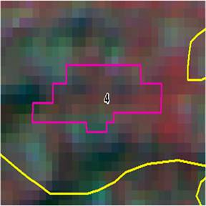

Longitude | 79.12832
Latitude | 13.19237
Area in Ha | 9.29
Change | OF to SF
Compt No | 450
Beat | Chasses Hills
Range | Chittoor
Division | Chittoor East

